AI Powered Personalised Study Planning and Learning Recommendation System

By

Kene Christopher Obiekwe
22120613021

Computer and Information Sciences Department
School of Science and Technology
Pan-Atlantic University

July, 2026

AI Powered Personalised Study Planning and Learning Recommendation System

By

Kene Christopher Obiekwe
22120613021

A project submitted to the School of Science and Technology, Pan-Atlantic University
in partial fulfillment of the requirements for the award of degree of Bachelor of Science (Computer Science) of Pan-Atlantic University.

July, 2026

Abstract
Undergraduate students often struggle to manage their study time effectively across multiple courses, leading to poor academic performance and increased stress. Existing digital study planners typically focus on static scheduling or content delivery with limited adaptive support for individual learning behaviour. This project presents the design, implementation and evaluation of StudyPilot AI, an AI-powered personalised study planning and learning recommendation web application that integrates academic preferences, available study time and recent behavioural signals to generate and continuously refine weekly study timetables. The system is implemented as a mobile-first Next.js client, a Django REST Framework backend secured with JSON Web Tokens, a PostgreSQL database and a Random Forest adherence prediction model trained on a canonical schema derived from the Open University Learning Analytics Dataset. The planner uses recent session adherence to re-weight allocations, and a rule-based engine produces strategy recommendations with a heuristic confidence score. The system was evaluated through two strands: a System Usability Scale survey of eleven undergraduate participants returned a mean SUS score of 61.82 (Grade C), and offline metrics on the held-out test set produced a Mean Absolute Error of 0.0291 and an R-squared of 0.957, an order-of-magnitude improvement over a mean-prediction baseline. The evaluation identified the system's onboarding flow as the principal area for future improvement, with a plan-first workflow gate recommended for the next iteration.

Keywords: artificial intelligence, study planning, adherence prediction, learning recommendation, System Usability Scale, self-regulated learning.

ACKNOWLEDGEMENTS
I am deeply grateful to God and my supervisor, Dr. Festus Oliha, for his patient guidance and constructive feedback throughout this project. I also thank my family for their unwavering support, and my friends and classmates at Pan-Atlantic University whose participation in the usability evaluation made this work possible.

Dedication
This project is dedicated to the Almighty God for seeing me through its entirety. I also dedicate this project to my family, friends and the general learning community.

STUDENT'S DECLARATION
I have read and understood the School of Science and Technology Policy on plagiarism. I declare that this project is my own work and that all sources are fully referenced. I also declare that I have not submitted this work for any other purpose.

____Kene Christopher Obiekwe___
22120613021

Date: ____21/01/2026____

CERTIFICATION
I certify that this work was carried out by Kene Obiekwe with matriculation number 22120613021, in the School of Science and Technology, Pan-Atlantic University, under my supervision.

________________________________
Supervisor: Dr or Prof Festus Oliha
School of Science and Technology
Pan-Atlantic University
Lagos, Nigeria

Date: ______________

Table of contents
1 Chapter One: Introduction
1.1 Background to the Study 1
1.2 Motivation 3
1.3 Research Problem 4
1.4 Aim and Objectives of Study 5
1.5 Methodology 5
1.6 Significance of Study 6
1.7 Scope of Study 6
1.8 Limitations of Study 6
1.9 Definition of Terms 7
2 Chapter Two: Literature Review
2.1 Conceptual Framework 8
2.1.1 Self-Regulated Learning in Higher Education 8
2.1.2 Study Planning and Time Management in Learning 9
2.1.3 Learning Analytics in Educational Systems 10
2.1.4 Artificial Intelligence in Education 12
2.1.5 Conceptual Relationship Between SRL, Learning Analytics, and AI 14
2.1.6 Mobile-Based Learning Support and Study Behaviour Regulation 16
2.2 Related Works 16
2.2.1 AI-Based Tutoring and Intelligent Learning Systems 17
2.2.1.1 Carnegie Learning Cognitive Tutor 18
2.2.2 Learning Analytics-Driven Study Support Systems 19
2.2.2.1 OU Analyse (Open University Learning Analytics System) 20
2.2.3 Adaptive and Personalised Learning Systems 20
2.2.3.1 Knewton Adaptive Learning Platform 21
2.3 Knowledge Gap 22
2.3.1 Limitations of Existing Self-Regulated Learning Support Approaches 22
2.3.2 Gaps in Learning Analytics and AI-Based Educational Systems 22
2.3.3 Contextual Gaps in Existing Studies (Undergraduate/Nigerian Context) 23
2.3.4 Proposed Solution 24
2.4 Summary of Literature Review 24
3 Chapter Three: Systems Analysis, Design and Production
3.1 Analysis of Existing 26
3.1.1 Case Studies 26
3.1.2 Weakness in Existing Systems 28
3.1.3 Proposal of New System 30
3.2 System Design 30
3.2.1 Overview of UML as the Design Tool 30
3.2.2 Use Case Diagram 31
3.2.3 Class Diagram 32
3.2.4 Sequence Diagram 33
3.2.5 Activity Diagram 34
3.3 Technology Stack 35
3.3.1 Overview of Selected Technologies 36
3.3.2 Frontend Technologies 36
3.3.3 Backend Technologies 37
3.3.4 Database and Additional Tools 37
3.4 AI Methodology and Model Development Process 38
3.4.1 AI Objectives and Prediction Tasks 38
3.4.2 Data Collection Strategy 39
3.4.3 Dataset Construction and Target Definition 39
3.4.4 Data Preprocessing and Feature Engineering 39
3.4.5 Model Selection and Training Procedure 40
3.4.6 Model Testing and Evaluation Metrics 40
3.4.7 Deployment, Monitoring and Retraining 40
3.4.8 Ethical and Reliability Considerations 41
4 Chapter Four: Implementation
4.1 System Requirements 42
4.1.1 Hardware Requirements 42
4.1.2 Software Requirements 44
4.1.3 Interface Requirements 45
` 4.2 System Execution/Output 46
4.2.1 Bringing Up Dependencies 46
4.2.2 Backup Startup 46
4.2.3 Frontend Startup 47
4.2.4 System Output Walkthrough 47
4.2.4.1 Authentication 48
4.2.4.2 Workspace Overview 49
4.2.4.3 Study Planner 50
4.2.4.4 Recommendations 51
4.2.4.5 Progress – Overview Tab 52
4.2.4.6 Progress – Log Session Tab 54
4.2.4.7 Progress – Predictor Tab 56
4.2.4.8 Progress – History Tab 57
4.3 System Evaluation 58
4.3.1 Evaluation Methodology 58
4.3.2 Participants and Procedure 60
4.3.3 Results and Analysis 61
4.3.4 Adherence Model Performance Metrics 63
4.3.5 Discussion 68
5 Chapter Five: Summary, Conclusion and Recommendations
5.1 Summary 70
5.2 Conclusion 70
5.3 Recommendation
References 72
Appendices 78

List of Tables
Table 4.1: Aggregated SUS results across eleven participants. 62
Table 4.2: Mean Absolute Error, Root Mean Squared Error and R-squared 64
for the mean-prediction baseline and the trained Random Forest model
on the held-out test set.

List of Figures

Figure 3.1: MyStudyLife Snapshot. 27
Figure 3.2: Snapshot of Brightspace Pulse app. 27
Figure 3.3: Carnegie Learning Snapshot. 28
Figure 3.4: Use Case Diagram of the system. 32
Figure 3.5: Class Diagram of the system. 33
Figure 3.6: Sequence Diagram of the system. 34
Figure 3.7a: Activity Diagram for Personalised Study Planning Workflow. 35
Figure 3.7b: Activity Diagram for Study Monitoring & Optimisation Workflow. 35
Figure 4.1: Landing page of the application. 48
Figure 4.2: Authentication screen showing the session access form and the side panel 49
describing the secured components behind the login.
Figure 4.3: Workspace overview displayed immediately after a successful login 50
Figure 4.4: : Study Planner page after submitting a plan request for twelve weekly 51
study hours across two courses.
Figure 4.5: Recommendations page returning a strategy set and a confidence 52
value for the supplied behavioural inputs.
Figure 4.6: Progress overview tab displaying the four key analytics tiles, the 54
course spotlight, the most recent sessions, the latest plan and
the latest recommendation.
Figure 4.7: Progress log session tab after submitting a study session, with 55
the adherence, predicted adherence, focus signal and
completion signal tiles updated.
Figure 4.8: Progress predictor tab returning an adherence forecast for 56
the supplied planned-session inputs.
Figure 4.9: Progress history tab showing the paginated list of planner plans. 57
Figure 4.10: Progress history tab continued, showing the paginated recommendation 58
events and session logs.
Figure 4.11: Distribution of System Usability Scale scores across the eleven 63
participants, with the dashed line marking the industry-average score
of 68 and the solid line marking the mean score recorded in this study.
Figure 4.12: Comparison of error metrics for the mean-prediction baseline 64
and the trained Random Forest adherence model on the
held-out test set.
Figure 4.13: Predicted adherence values plotted against the true adherence 65
values for a sampled subset of the held-out test set.
Figure 4.14: Distribution of the residuals (true adherence minus predicted adherence) 66
for the held-out test set.
Figure 4.15: Feature importance values produced by the trained Random Forest 67
adherence model, with completion_rate near zero confirming that
the target-leakage issue identified during construction was resolved.
Figure A.1: System architecture and component layout, showing the layered 78
deployment of the Next.js client, the Django REST backend with its
four apps, the PostgreSQL database and the trained adherence model artifact.
Figure A.2: Entity relationship diagram of the persistence layer, showing the User 79
entity at the centre and the four related tables (Course, StudyPlan,
RecommendationLog and StudySessionLog) each linked through a
foreign key on the user identifier.
Figure A.3: Machine learning pipeline and inference data flow, showing the training 80
pipeline that builds the canonical dataset from OULAD and
trains the Random Forest model, the inference path through
the tracking module, and the feedback loop that supports future
domain adaptation from in-app data.

Chapter One: Introduction

Background to the Study
To be a successful higher education student, it is essential to plan study sessions and manage time properly to be productive. Higher learning students must possess a high degree of autonomy in order to meet their academic requirements. The independent structuring of learning patterns, the possibility to combine several courses and subjects and the maintenance of the regular studying habits are some of these requirements. The studies indicate that planning and controlling of studying and learning activities are the tasks that many students cannot undertake on their own and as a result, use their study time ineptly, experience academic stress, and perform poorly in general (Zimmerman, 2002; Broadbent, 2017).

The idea of self-regulated learning enables a better understanding of how students manage and plan their studies. Self-regulated learners readily organize learning tasks, establish goals, monitor progress and proactively amend learning strategies based on feedback (Zimmerman, 2002). Findings from research in higher education point towards the evidence that students who make use of self-regulation and time management approaches academically outperform others who employ unstructured study habits (Broadbent, 2017; Schraw, Crippen, & Hartley, 2006). Many students across higher education still rely on unregulated study patterns or casual decision-making processes that are difficult to maintain and lead to poor results despite the evidence that self-regulation in learning is effective.

Digital technology advancements have made it easy to assist the study patterns of students through adaptive and data-driven systems. The use of learning analytics and artificial intelligence for the analysis of study behaviours, feedback provision and personalized learning support in higher education is rapidly increasing (Viberg et al., 2018; Ifenthaler & Yau, 2020). These data-driven advancements crucially inform learners on potential techniques to improve their study planning and learning efficiency based on the system's insight of student or learner data. However there is a fragmentation of existing systems due to their focus on learner performance monitoring rather than continuous support for personalized study organisation (Viberg et al., 2018).

Learning experiences are being enhanced by artificial intelligence-based educational systems through its features of content adaptation and support for individual learner needs. Studies related to intelligent tutoring systems (ITS) and artificial intelligence-supported learning spaces point towards positive and progressive effects on the academic performance and engagement of learners (Kulik & Fletcher, 2016; Kim et al., 2020). There is still a limited emphasis on personalized time management or timetable generation and optimisation which remains a central challenge for students across higher education.

The opportunity of mobile-based systems as the primary platform for planning study support is derived from the widespread use of smartphones by the general population of higher education students. The use of smartphones has become a daily habit for students hence utilizing integrated mobile platforms for delivering reminders, notifications and personalized learning support is a suitable idea (Oulasvirta et al., 2012). Still, there is very limited exploration into the use of mobile platforms to regulate personalized study time management and optimisation.

In developing countries like Nigeria there are many higher educational institutions that have limited access to advanced educational digital technology which features personalized learning support for students. There is a need for adaptive and context-aware artificial intelligence-driven educational solutions tailored towards diverse learner needs according to global policy and research reports (Miao & Holmes, 2021). Regardless of a growing interest in digital educational tools there is an apparent scarcity of integrated systems that utilize a combination of self-regulated learning methodologies, artificial intelligence-supported systems and mobile technologies to aid learners' study patterns and help with effective time management.

There is a clear gap in the development of intelligent and mobile-based study planning systems that make use of artificial intelligence and learning analytics to support personalized study planning particularly within higher educational institutions in developing countries such as Nigeria.

Motivation
Regardless of the necessity of competent study planning and time management for students in higher education, it remains a difficulty for them. Many learners often struggle to marshal their learning routines and allocate time efficiently across courses or subjects which inevitably leads to poor academic performances and increased stress (Broadbent, 2017). Only on rare occasions do tactics for study planning take into account the adaptation to individual learning behaviours or patterns. These tactics may include manual timetables and self-structured scheduling.

Even though recent digital technology advancements aid learning and content delivery through artificial intelligence-supported systems that use learning analytics, there is still a gap that is not focused on, which is the lack of coverage on personalized learning feedback and time management support (Viberg et al., 2018; Ifenthaler & Yau, 2020). Many of these current systems do not function in conjunction with individual learners' study routines, which in turn limits their effectiveness in aiding organized study habits.

Artificial intelligence-supported learning systems, like intelligent tutoring systems, positively influence learner or student engagement and achievement (Kulik & Fletcher, 2016; Kim et al., 2020). However amidst this, these systems fail to tackle the challenge of providing personalized time management support and promoting progressive learner behaviours. This results in learners being left with inadequate learning tools in higher education.

The use of smartphones among students in higher education, provides an opportunity to deliver an intelligent learning support tool on mobile platforms. Studies signify that regular smartphone use can fortify daily habits through mobile notifications or reminders (Oulasvirta et al., 2012). This potential has not been fully harnessed to enhance learning habits in students.

Research Problem
In the context of Nigerian higher education the difficulty is made worse by a restricted access to unified and adaptive learning support systems that address varied student demands and infrastructure obstacles. Even though people all over the world want artificial intelligence-based solutions in education that are open to everyone and take into account the context (Miao & Holmes, 2021) there aren't any smart, mobile-based systems that use self-regulated learning principles, artificial intelligence and learning analytics to make or improve personalized study schedules for students. This gap shows that university students need a system that can help them manage their studies and encourage good learning habits.

Aim and Objectives of Study
The aim of this study is to build an AI-powered study planning and recommendation system dedicated towards improved academic outcomes for students in higher education.
Objectives:
- Propose an intelligent study planning system that integrates academic performance data, learning preferences and available study time to generate or optimise personalized study timetables.
- Design and implement the system using appropriate artificial intelligence and software development methodologies to enable features like adaptive study scheduling and learning strategy recommendations.
- Evaluate the developed system’s ease of use, learning effectiveness and study efficiency using evaluation metrics and user feedback.

Methodology
This study adopts a system-oriented design approach focused on the analysis, design and development of an AI-powered personalised study planning and learning recommendation system. The methodology involves finding gaps in existing systems, proposing an improved system and modelling the system using Unified Modeling Language (UML). The proposed system is designed as a mobile-based and mobile-first application that makes use of rule-based logic with basic machine learning techniques to support adaptive study timetable management and learning strategy recommendation. Key student inputs such as academic workload, study preferences and available time are analysed to generate and optimise personalised study plans. The system design and technological choices are detailed in Chapter Three which provides a foundation for subsequent system implementation and evaluation.

Significance of Study
This project is important for students, teachers, and the area of computer science. It gives students a personalized and flexible way to schedule their studies that matches their learning styles with their demands which makes studying more productive. The system shows educators and schools how artificial intelligence may be used to help students learn on their own outside of the classroom. From a computer science point of view, the project adds to applied research in artificial intelligence, data-driven decision-making and educational technology by combining machine learning, system design and mobile computing into one solution.

Scope of the Study
The scope of this project is limited to the development of a software-based system that generates or optimises personalised study timetables and learning strategy recommendations. The system's main job is to look at academic performance data, figure out how students learn best, suggest learning recommendations and send reminders to study through a mobile or web interface. It doesn't try to replace conventional teaching methods or guess how examinations will turn out.

Limitations of Study
A key limitation of this study is the domain gap between external training datasets and the target undergraduate context. Although external datasets provide sufficient volume and reliability for initial model development, proxy based feature mapping may not fully capture local study habits, curriculum structures, and institutional factors. As a result, recommendation and optimisation performance may vary across student groups until sufficient in-app behavioural logs are gotten for adaptation and retraining.

Definition of Terms
- Artificial Intelligence (AI): The use of computer methods that let computers act like they can make smart decisions.

- Personalized Study Timetable: A study timetable that changes based on how well a student is doing in school, how they want to learn, and how much time they have to study.

- Learning Analytics: The process of gathering and analysing data on learners in order to make reports that help people understand and improve how they learn.

- Self-Regulated Learning: When students can organize, keep track of and judge their own learning activities.

- Mobile Reminder: A message sent to a mobile device to remind you to do your scheduled study activities.

Chapter Two: Literature Review

Conceptual Framework
This section offers the main hypotheses and important ideas that form the basis of the planned research. It establishes the theoretical basis for comprehending self-regulated learning, study planning and time management, learning analytics and artificial intelligence in educational systems.

Self-Regulated Learning in Higher Education
Self-regulated learning (SRL) is the capacity of the learner to plan, monitor and evaluate his or her learning activity. It also involves learners assessing the cognitive, motivational and behavioural activities. SRL encompasses a broad field that influences the process of learning and includes cognitive processes, metacognitive mindfulness, motivation and regulating emotions hence, it is an inclusive model to examine how students become engaged in academic pursuits (Panadero, 2017). Self-regulated learners are self directed students who assume the roles involved in goal setting and change of strategies in their learning in order to attain what they want.

The rise of SRL in higher education is as a result of greater independence which students get. According to Zimmerman and Schunk (2011), self-regulated learners are ambitious people, who consciously activate and maintain thoughts, emotions and behaviours that are goal focused in meeting learning objectives. Such learners know their strengths and weaknesses and they are also directed by the goals that they set themselves and task specific strategies. These plans include a cognitive design of learning that is broken down into three stages: forethought, where the students identify goals and strategize; performance, where students employ strategies such as breaking down tasks, imagery, and structuring of the environment; and self-reflection, which is where students assess their learning to enhance their future learning. This is a methodical selection of strategies that enable the students to overcome the tricky academic settings easily.

There is empirical evidence that indicates the close association that exists between self-regulated learning and academic performance in institutions of higher education. According to Ifenthaler and Yau (2020), SRL is a key to the success of study since it directly affects the capacity of students to cope with learning activities, especially in online and independent learning platforms. They also note that too many university students had impaired self-regulation skills that could result in poor performance in school. This is heightened by the high use of digital learning whereby effective learning is reliant on the capability of the students to control their study behaviour independently.

Study Planning and Time Management in Learning
Two of the most important aspects of self-regulated learning particularly in higher learning institutions are study planning and time management where students are supposed to be in an autonomy of arranging their own learning processes. Planning is concerned with determination of learning objectives and allocating time and resources to academic endeavours and time management is the responsibility of scheduling and controlling the study time towards achievement of the objectives (Jansen et al., 2019).

The existing empirical findings indicate that planning and time management skills are good predictors of academic success and advancement in the university environment. As Ifenthaler and Yau (2020) point out, the capacity of students to organize their learning activities and manage their time have a close connection with the success of the study particularly in digital and blended learning environments. Many learners continue to have difficulty in planning their studies alone without supervision and this can have an adverse impact on academic achievements.

Time management has been found to be related to positive academic performance significantly. Students who have to plan their study time adequately and manage their learning sessions are likely to get better grades which underlines the significance of systematic planning of studying in the conditions of self-regulated learning (Broadbent & Poon, 2015). The challenges faced by learners are compounded by the growing flexibility of online learning whereby poor planning can easily result in procrastination and study behaviour ineffectiveness.

Recent studies indicate that data driven and feedback oriented systems have the potential to facilitate the planning and time management of the students. According to Matcha et al. (2019), self-regulation includes all the processes involved in choosing good learning strategies but also knowing when and how to implement them, something most students do not have. Systems based on learning analytics can solve this issue by offering information about engagement processes and time on task behaviours in students that can be used as indicators of planning efficiency and engagement in studying (Ifenthaler & Yau, 2020).

Learning Analytics in Educational Systems
Learning analytics (LA) can be defined as the process of gathering and analyzing information about learners with a view to producing reports that would contribute to learning processes in understanding and refining them. According to Sousa et al. (2021), learning analytics is a measure that builds on data concerning students and their frameworks to create significant feedback, improve learning results and aid judgment among educational actors. On the same note Viberg et al. (2018) describes learning analytics as the process of measuring and analyzing learner information to optimise learning and learning environments in which learning takes place as an indicator of its popularity in higher education.

It is a well-known fact that this systematic process is a multidisciplinary area that utilizes artificial intelligence, machine learning, statistics, and social sciences to analyse educational data (Drachsler & Greller, 2016). This socio-technical quality of learning analytics enables their systems to go beyond mere reporting of data to more sophisticated modelling, prediction and optimisation of the learning processes (Ifenthaler & Yau, 2020). These types of system are becoming more prevalent in higher education establishment in an attempt to learn more about the student behaviour, level of engagement, and academic development.

Much learning analytics research has been conducted on academic performance prediction and risk prediction of poor academic performance in students. The article by Ifenthaler and Yau (2020) informs about the evidence that numerous learning analytics applications seek to facilitate the success of study by early alert and specific feedback according to the interactions between the students and their learning environments. The learning analytics systems have these predictive and diagnostic properties that allow educators and institutions to intervene in the learning process of students proactively and not reactively.

The learning analytics is also involved in learning to know how the students learn on a grand scale. According to Matcha et al. (2019), a learning trace, including time spent on activities and interaction sequences, can be studied to see the learning strategies used by students without interfering with the process of learning or putting an additional cognitive burden on it. The significance of process oriented analytics that studies the sequential and procedural nature of learning in order to timely give feedback during learning processes rather than with the results of the assessment, is also demonstrated by Sedrakyan et al. (2020).

Recent studies also demonstrate the significance of feedback that is customized on a personal and context-specific level in learning analytics systems. Lim et al. (2021) maintain that learning analytics is applicable to create learning metrics and benchmarks that can be presented to students with the help of dashboards or personalised messages. They also warn that generic analytics models are not always able to meet the needs of individual learning, which point to the need to improve the methods. Learning analytics systems may process a substantial amount of learner data in combination with AI and deliver timely feedback and insights on learning patterns boosting their potential to support effective study behaviours (Tang, 2024).

Artificial Intelligence in Education
Artificial Intelligence (AI) in education can be defined as the application of computational methods to allow systems to replicate intelligent decision making to facilitate the teaching and learning activities. According to Chu et al. (2022), AI technologies are systems that have human like capabilities thus allowing them to analyse educational data and carry out complex functions such as profiling learners, predicting academic performance and identifying those learners at risk of low performance. The characteristics have made AI a highly significant learning resource in the contemporary learning setup.

Artificial Intelligence in Education (AIEd) is an inherently interdisciplinary field that incorporates aspects of artificial intelligence with other fields like education, psychology and philosophy to improve the comprehension and to create learning in various contexts (Luckin et al., 2016). The initial uses of AI in education such as Intelligent Tutoring Systems (ITS), were based on a set of rules and quite limited error detection. The current advances in machine learning, neural networks and data-driven algorithms have provided a means to more adaptable and autonomous systems that can customise learning material based on the vast amount of learner data (Luckin et al., 2016).

The existing uses of AI in learning are inclined to pay more attention to personalisation and adaptive support. According to Tang (2024), AI based learning services compute data of students such as learning style, learning habits and activity rates to provide customised content, feedback and suggestions. Intelligent tutoring systems even go as far as to offer personalised instructions and feedback that replicates the functions of human tutors and assist the learners through the learning process.

The role of AI is also quite powerful in facilitating the real-time interventions that can be adapted to the process of self-regulated learning. Wu et al. (2026) emphasize that AI based systems of education can encourage students to establish their objectives, track the accomplishment of the tasks and analyze the performance thus, proactively assist in planning, monitoring, and reflection. The interventions are especially useful in the context of digital learning when the learner has to assume complete control over the study behaviour.

There has finally been a shift from teacher-centred to learner-centred education by enabling personalised, adaptive and data-informed learning experiences which AI contributes to (Tang, 2024). In higher education, AI serves as a foundational learning technology that enhances feedback, prediction and instructional support which forms a critical component of intelligent learning systems.

Conceptual Relationship Between SRL, Learning Analytics, and AI
Self-regulated learning, learning analytics, and artificial intelligence are conceptually linked because they all focus on helping learners plan, monitor and regularly adjust their learning activities. SRL provides the theoretical explanation of how learners regulate their learning process phases while learning analytics and artificial intelligence provide the technological aspects through which these processes can be observed, analysed and supported within digital learning environments.

Learning analytics functions as a foundational layer by capturing and analysing data related to learners’ interactions, behaviours and progress. By giving students information about their learning processes, learning analytics systems can help with self-observation and reflection which are key components of the SRL cycle (Zimmerman & Schunk, 2011; Ifenthaler & Yau, 2020). Through personalised and timely feedback, learning analytics aids learners to plan their activities, monitor progress and evaluate outcomes thereby strengthening their self-regulatory capabilities (Matcha et al., 2019; Viberg et al., 2018).

Artificial intelligence assists and enhances the functions of learning analytics with its capability of automatic interpretation, prediction and adaptive intervention. Given the ability of AI systems to process learning analytics data within seconds, they can provide both personalised feedback to support learners in the process of regulating goals, strategies and behaviours (Molenaar et al., 2023; Wu et al., 2026). This way, AI will serve as a kind of external regulator that will supplement the internal processes of self-regulation in learners by encouraging them to reflect, alter their strategies and work on their tasks when necessary.

The integration and application of AI and learning analytics make up a feedback system that is consistent with the characteristics of self-regulated learning that is circular. The information gathered on learners gets fed to AI based analysis that creates adaptive feedback and personalised support that affects subsequent learning behaviours (Tang, 2024). The process allows implementing proactive interventions that facilitate the capacity of students to regulate their learning in autonomous contexts of higher learning (Lim et al., 2021; Sedrakyan et al., 2020).

Ethical and trustworthy implementations of these technologies are also important to make them effective. According to Drachsler and Greller (2016), the learning analytics and AI systems should strike a balance between the capabilities of the systems to the rights of the learners, transparency, data protection and informed consent. It is highly important that the systems and learners can build trust so that meaningful data exchange and personalised support become possible.

Mobile-Based Learning Support and Study Behaviour Regulation
Mobile-based learning systems can effectively facilitate the regulation of study behaviour in the context of students in the university since smartphones are widely used by students. Mobile learning environments assist learners in dividing their study activities into small and manageable pieces or periods that facilitate time management and involvement in academic activities (Hattie, Sahlberg, & Comer, 2023).

The digital reminders that are sent through the mobile applications in the devices are also another unnoticed intervention that removes the lapse of attention among students towards the current academic tasks and deadlines they are experiencing. These reminders systems have been demonstrated to facilitate self-regulated learning by contributing to the task awareness and prompting a follow through on the intended study tasks (Nobbe et al., 2024). Mobile-based automatic reminders are more effective at supporting learning behaviours and continuing to be organised and focused on studying, as compared to passive communication, such as emails, or a static learning management system, because they are timelier and more actionable (Lai et al., 2020).

Related Works
This section examines the available research studies and applied systems in reference to my intended project idea. It analyzes some of the AI based tutoring systems, learning analytics based study support platforms and adaptive learning systems that are pertinent to the proposed study. Through their analysis of the design and application of these systems, this section identifies their contributions, limitations and applicability in aiding students to self-regulate learning and plan their studies in higher education.

AI-Based Tutoring and Intelligent Learning Systems
Intelligent tutoring systems, also referred to as AI based tutoring systems, have been extensively employed in educational settings to deliver regularly adapted learning and customized instructional coverage. Such systems are aimed not only to model the knowledge states of the learners but also to provide customised feedback, support and teaching guidance on the basis of the current learner performance. It has been discovered that self-regulated learning can be facilitated by intelligent tutors who facilitate students to engage actively with learning materials and make decisions supported by information regarding how and when to access teaching aids (Nagashima et al., 2022).

The use of intelligent tutoring systems by students is significant in the process of learning. Nagashima et al. (2022) have discovered that students who constantly interacted with AI offered assistance like the selection of visual representations that is based on self-observation demonstrated higher learning development than students who depended on the prompts of the reactive system. This is an indication that intelligent tutoring systems will be effective when they motivate learners to be able to manage their learning behaviours as opposed to unknowingly following system direction.

Modern intelligent tutoring systems rely on data driven learner modelling techniques to help provide adaptive instructions. Stinar et al. (2025) identify Bayesian Knowledge Tracing (BKT) as brilliant approach used to estimate learners’ ability to master specific skills by continuously updating incomplete knowledge states based on performance data. Systems such as Carnegie Learning’s MATHia employ BKT to personalise learning paths and provide instructional support in real time which then ensures that feedback and task difficulty is in line with individual learner needs.

Feedback and scaffolding mechanisms are central features of intelligent tutoring systems. Huang et al. (2024) highlight that data driven and elaborated feedback helps to reduce the cognitive load of learners by making timely hints and explanations tailored to specific errors available to them. Borchers et al. (2025) also mention that the modern tutoring systems offer a step by step support framework which directs the learners in problem solving exercises using various adaptivity levels based on the design. These are the features which enable intelligent tutors to replicate the elements of human tutoring in order to facilitate problem solving and self-regulation by learners.

Carnegie Learning Cognitive Tutor
Carnegie Learning Cognitive Tutor is an intelligent tutoring system invented by scholars of Carnegie Mellon University under the leadership of John R. Anderson and others and is informed by artificial intelligence methods. The system was made to assist the learning of mathematics based subjects where the states of the knowledge of the students were modeled and step by step instructions were provided when the students were going through problem solving exercises.

The Cognitive Tutor can modify the teaching in real-time by examining the responses of the students and detecting any gaps in their knowledge allowing the delivery of personalised hints, feedback and practice questions or tasks. It takes advantage of the learner modelling approaches such as Bayesian Knowledge Tracing to estimate the competence of particular skills in the students and modify the teaching materials. The Carnegie Learning Cognitive Tutor demonstrates that AI based tutoring systems can offer individually tailored learning resources in the context of higher education, through its adaptive scaffolding and feedback.

Learning Analytics-Driven Study Support Systems
Learning analytics motivated study support systems are aimed at helping both students and educators to examine the learning information with the purpose to determine the patterns in the data in relation to the risk of academic risk and learning progression. The latest trends indicate that descriptive or predictive analytics are replaced by prescriptive analytics advising on a course of action to enhance learning results (Herodotou et al., 2025). The aim of these systems is to facilitate self-regulation, whereby the systems give the students information and advice to facilitate in decision making in what they study.

Early risk detection is one of the main characteristics of learning analytics based study support systems. According to Hlosta et al. (2022), predictive learning analytics systems use digital learning environments and student records to draw conclusions about those learners at risk of academic failure especially with the use of such indicators as low engagement or academic failure. These systems allow preventive interventions and tailored support that are required to ensure the success of the students in their studies by identifying the risk at an early stage.

Large scale institutional implementation is another way of demonstrating the effectiveness of learning analytics driven support systems. According to Boroowa and Herodotou (2022), OU Analyse system utilizes machine learning methods to generate routine predictions of student results on the basis of various data such as engagement as well as assessment information. Their results show that such systems can assist teaching practices by promoting more active support of students hence enhancing the entire study support ecosystem.

OU Analyse (Open University Learning Analytics System)
OU Analyse is a learning analytics driven study support system developed by The Open University in United Kingdom. The production was led by researchers such as Carolyn Penstein Rose, Rebecca Ferguson and Christothea Herodotou. The system was made for the support of large scale distance and blended learning by identifying students at risk of poor academic outcomes.

The system operates by analysing data from multiple sources including virtual learning environment interactions, assessment records and student demographic information. OU Analyse generates regular predictions related to student engagement and assignment submission while making use of machine learning models. These predictions are used to provide instructors and support staff with insights that enable early, proactive and targeted interventions aimed at improving students’ study progression and retention.

Adaptive and Personalised Learning Systems
Adaptive and personalised learning systems are made to align learning experiences to individual learners by adjusting content, feedback and instructions based on learner characteristics and performance. These systems address the limitations of traditional one size fits all instructional methods by providing customised learning experiences that respond to individual learner needs, preferences and progress (Chu et al., 2022).

Research indicates that adaptive learning systems support learning by integrating step by step supporting mechanisms that enhance learners’ metacognitive and self-regulatory processes. Ouyang (2025) explains that such systems act as psychological tools that interact with learners’ internal regulation processes enabling improved monitoring, control and engagement during learning activities. Through these adaptive features, personalised environments promote better engagement and improved academic outcomes by first strengthening self-regulated learning behaviours.

The point of view of the system design shows how adaptive learning environments depend on organised models aid personalisation processes. According to Luckin et al. (2016), these systems are characterized by a learner model, which is the reflection of knowledge and specifics of the learner at the moment, a domain model, which enforces the topic content, and a pedagogical model, which presupposes what kind of instructional approach should be applied. These model elements allow the adaptive systems to modify instructional materials in a manner that is sensitive to individual needs and learning situations of learners.

Knewton Adaptive Learning Platform
Knewton is an adaptive learning platform developed by Knewton Inc. The platform was designed to produce personalised learning experiences by analysing learner performance data and adjusting instructional content in real time.

Knewton was made to function by making use of algorithms that model learners’ knowledge states and learning behaviours to prescribe appropriate learning materials, activities and assessment pathways. By continuously updating these prescriptions based on learner interactions, the system adapts content difficulty to match individual learning needs. Knewton has been widely integrated into digital textbooks and online courses which serves as a prominent example of an AI driven personalised learning system.

Knowledge Gap
This section combines ideas from the literature and related systems to find problems with the current ways of helping higher education students learn on their own. By analyzing deficiencies in existing self-regulation support mechanisms, learning analytics applications and AI driven educational systems particularly in undergraduate and local contexts, the necessity for the suggested system is established, elucidating its role in fulfilling these unfulfilled requirements.

Limitations of Existing Self-Regulated Learning Support Approaches
Although self-regulated learning has been widely recognised as a determinant of academic success in higher education, existing methodologies to supporting SRL remain largely theoretical or instructor dependent. Many interventions rely on students’ individual capacity to regulate their learning without providing sustained system level support. Where SRL tools do exist, they are often fragmented or limited to static guidance that does not account for students’ evolving learning behaviours. As a result learners in autonomous and digital learning environments continue to struggle with proper study planning and time management.

Gaps in Learning Analytics and AI-Based Educational Systems
There are numerous gaps in the way students learn with respect to the applications of learning analytics and AI-driven educational technologies despite the improvements in the field. Most of the systems concentrate on prediction and risk identification such as assuming that a student is likely to perform poorly or dropout instead of offering sustained and practical assistance to learners. This means that insights produced by analytics tend to be retrospective or instructor-facing and, hence, does not directly benefit students.

Current AI driven systems in educational contexts are often designed as single standalone tools that address specific aspects of learning like content adaptation or performance forecasting. They do not integrate core self-regulated learning processes like goal setting, time management and reflective feedback. This lack of integration reduces their effectiveness in helping students develop good study habits. Many systems are developed and evaluated in well resourced contexts with limited consideration for various constraints in developing higher education environments thereby restricting their applicability and impact in contexts like Nigerian universities.

Contextual Gaps in Existing Studies (Undergraduate / Nigerian Context)
Most studies on learning analytics, artificial intelligence, and self-regulated learning have been conducted in developed countries and are situated within technologically advanced education environments. Their findings and proposed systems most times assume reliable internet access, a widespread availability of learning management systems and high levels of digital literacy. These conditions do not consistently reflect the realities of many Nigerian universities.

Existing research tends to focus on generic student populations with comparatively less attention given to undergraduate students who are still developing effective study planning and self-regulation skills. In the Nigerian context where large class sizes and limited academic support structures are common, there is a lack of context aware, student centred systems designed to support undergraduate learners’ study planning and learning routines. This gap points towards the need for solutions that are tailored to the institutional constraints of Nigerian undergraduate students.

Proposed Solution
To address the identified gaps from the earlier sections, this project proposes an intelligent study support system that integrates self-regulated learning principles, learning analytics, artificial intelligence and learning strategy recommendation. The system functions to generate personalised study timetables or optimise existing ones and recommend appropriate learning strategies based on students’ learning behaviours, academic requirements and individual goals. The system offers adaptive guidance and focused feedback and strategy recommendations through the interaction data of the learners. The objective of this approach is to enhance sustainable study behavior and enhance academic achievement among undergraduate students, more so in the Nigerian higher education setting.

Summary of Literature Review
This chapter reviewed some literature on self-regulated learning, learning analytics, artificial intelligence in education, and mobile based learning support systems. The review showed that SRL is central to academic success with its integrated cycle of forethought, performance, and self reflection. It was also established that students often require external support to navigate the SRL cycle. It also highlighted the role of learning analytics and AI in providing personalised feedback, adaptive support and data driven insights to enhance students’ learning experiences.

The related works analysed existing AI based tutoring systems, learning analytics driven study support systems and adaptive learning systems that demonstrated their potential to support self-regulation and personalised learning. The review also identified key limitations like limited integration of learning strategy recommendations and insufficient consideration of contextual factors like undergraduate learning environments in Nigeria.

Chapter Three: Systems Analysis, Design and Production

Analysis of Existing System
This section contains an analysis of similar or existing study planning and learning support systems to identify their functionalities and limitations. The analysis shows the gaps which may exist within the systems as well as a need for a new integrated intelligent system which this project proposes.

Case Studies
There is currently no single existing system that has a full integration of personalised study time management with learning strategy recommendation using artificial intelligence. Several digital learning support systems do incorporate individual features that align a bit with the objectives of this study. These systems were selected and brought forth as case studies. The first selected system is MyStudyLife which is a widely used mobile based study support application used to help students organise their academic schedules.

MyStudyLife as in Figure 3.1 provides students with tools to manage class timetables, examinations and academic deadlines through a single digital application. The system allows users to input course schedules and receive reminders for upcoming academic tasks which acts as a means of supporting basic study planning and time management. As a mobile based tool, it makes it more accessible and supports students in organising their academic activities across their personal devices. MyStudyLife captures aspects of proper study organisation that are relevant to personalised study planning through its scheduling and reminder functionalities.

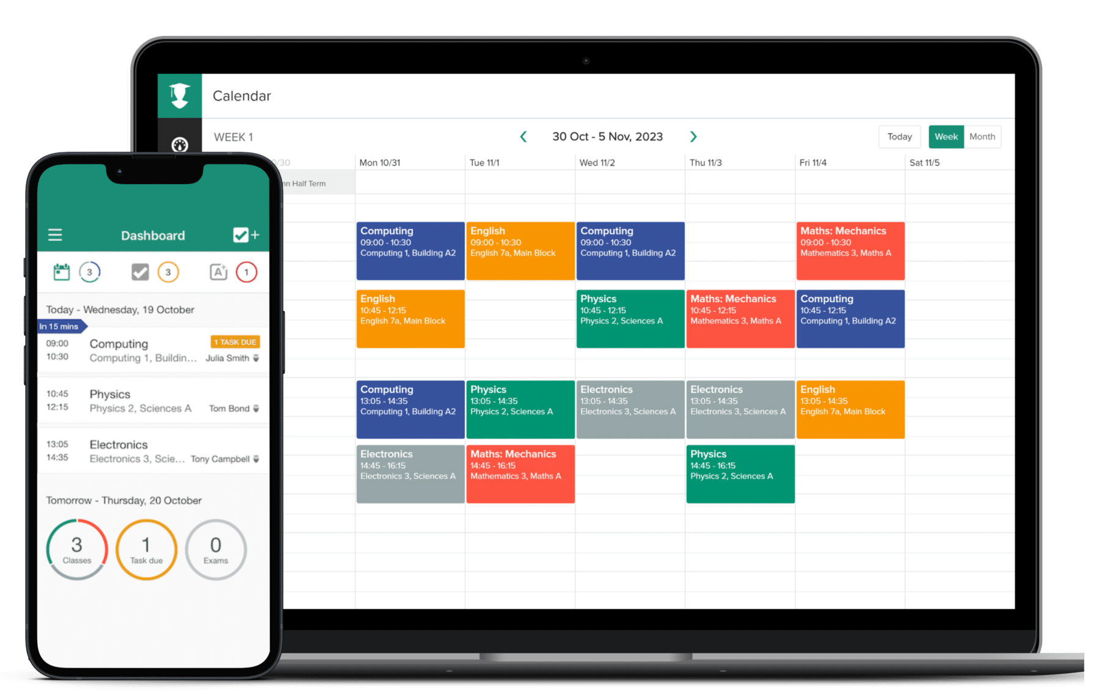

Figure 3.1: MyStudyLife Snapshot

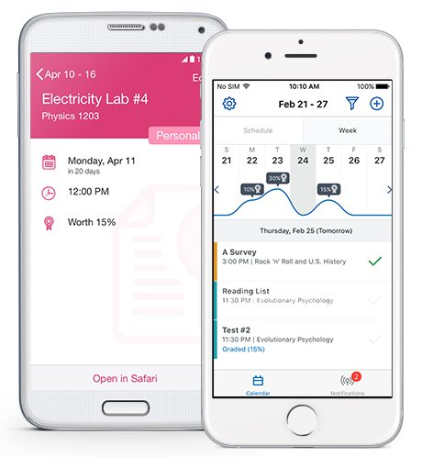
The second system in Figure 3.2 below is Brightspace Pulse which is a mobile application integrated with the Brightspace Learning Management System. Brightspace Pulse delivers notifications related to course activities, deadlines and learning resources which enables students to stay informed about their academic responsibilities. By compiling learning related information and providing timely alerts the system then supports learner awareness and engagement within digital learning environments. Its analytics driven notifications reflect the use of learner data to inform learning decisions which is aligning with learning analytics components relevant to this study.

Figure 3.2: Snapshot of Brightspace Pulse app
The final case study is Carnegie Learning’s Cognitive Tutor (MATHia) which is shown in Figure 3.3 below. It is an artificial intelligence based tutoring system designed to provide personalised support to learners. The system uses learner modelling methods to adjust content, feedback and problem difficulty. Carnegie Learning demonstrates how artificial intelligence can be applied to personalise learning support by aligning learning experiences to individual learners. Although focused on subject specific instruction, the system has the potential of AI-driven personalisation that informs the design of intelligent study support solutions.
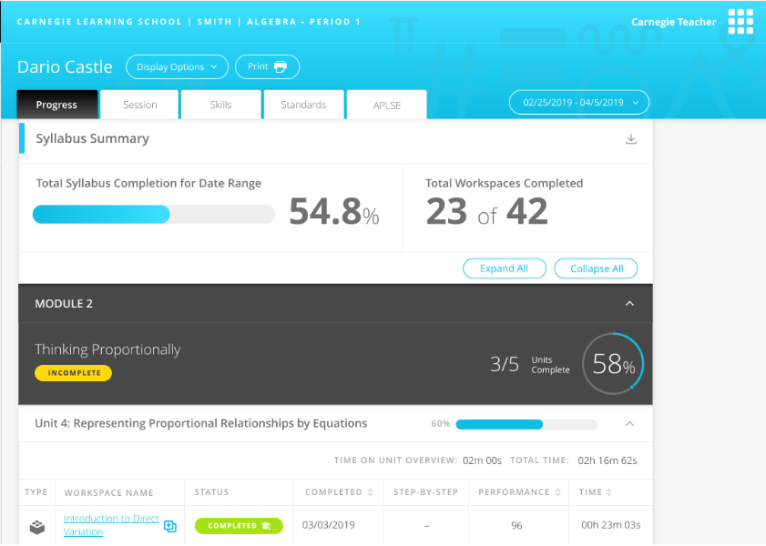

Figure 3.3: Carnegie Learning snapshot

Weaknesses in Existing Systems
The reviewed systems have intelligent features like automated reminders, adaptive content delivery using artificial intelligence based algorithms, digital timetable support and study planning to assist students with study organisation. These features are made to work independently and do not collectively support personalised time management through adaptive measures and intelligent learning recommendation prescriptions.

MyStudyLife offers simple scheduling and reminder capabilities but instead of depending on dynamic structures of timetables they require hand entry maintenance and manual scheduling. Although it aids in the organisation of studies, it does not add value to examining the academic performance, study behaviour and learning preferences of learners to help in the creation of learning schedules dynamically. The system also does not have any types of recommending suitable learning strategies or modifying study plans due to some changes in the working load, performance and time availability.

Brightspace Pulse provides deadline awareness and analytics driven notifications by being integrated with an institutional learning management system. Nonetheless, it is mainly concerned with information delivery as opposed to planning of the actual study or behavioural control.

Finally, the Cognitive Tutor by Carnegie Learning has high level of artificial intelligence due to its adaptive content delivery and personalised instructional feedback but personalisation is restricted to subject based learning exercises in predefined instruction settings. The system does not accommodate the larger academic planning requirements of workload in cross courses, time utilization or scheduling of individual studies. It also does not suggest the learning strategies in various courses or study backgrounds which limits its levels of application as an integrated study management system.

A common limitation in the 3 systems is the absence of an integration that combines learning analytics, artificial intelligence and self-regulated learning principles to support personalised study planning and recommendation.

Proposal of the New System
Current learning systems are mostly content delivery systems, just like the digital libraries or lecture halls, where students have access to learning materials but the systems do not actively manage the study activities of the students. The suggested system is intended to run as an intelligent study manager overlaying these platforms combining artificial intelligence, learning analytics and self-regulated learning philosophies to help manage adaptive study schedule planning and provide learning strategy advice. The system is able to coordinate and optimise study activities across courses by analysing learner behaviour and academic requirements as well as available study time which is an issue with the current systems where scheduling, analytics and smart support have been adopted on an individual basis. This holistic student based learning support system offers a student centred approach to the learning process that facilitates good study habits and academic success.

System Design
This section is the system design which will focus on how components of the proposed system and interactions are structured to support personalised study planning and learning method recommendation. Unified Modeling Language (UML) used to model the system through standard design diagrams.

Overview of UML as the Design Tool
Unified Modeling Language (UML) is used in this study to visually represent the structure and behaviour of the proposed intelligent study support system. UML diagrams provide a clear way to model system interactions, data components, and process flows involved in personalised study planning and learning strategy recommendation.

Use Case Diagram
Figure 3.4 illustrates the use case diagram of the proposed AI-powered personalised study planning and learning recommendation system. It shows the student as the primary actor interacting with the system to perform key functions such as registering and logging in, inputting academic details, specifying study time and preferences, planning study goals, generating and optimising personalised study timetables, receiving learning strategy recommendations, tracking study progress and performance, reviewing feedback, and receiving intelligent reminders and notifications. The diagram highlights how the system supports effective study planning and self-regulated learning through continuous and adaptive user interaction.

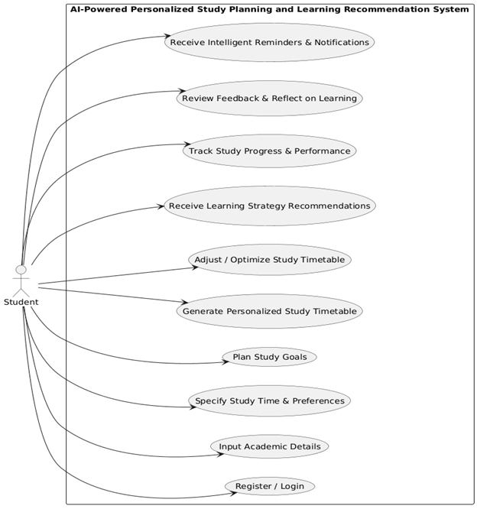

Figure 3.4: Use Case Diagram of the system

Class Diagram
Figure 3.5 presents the structural design of the proposed AI-powered personalised study planning and learning recommendation system. It illustrates the main classes, their attributes and the relationships between them. The Student class is to be the primary user and is associated with courses, a personalised study timetable and learning strategies. Components like the RecommendationEngine and ProgressTracker support the feature of adaptive timetable optimisation, learning strategy recommendation and performance monitoring while supporting classes like StudySession and Notification enable study activity tracking and reminder delivery.
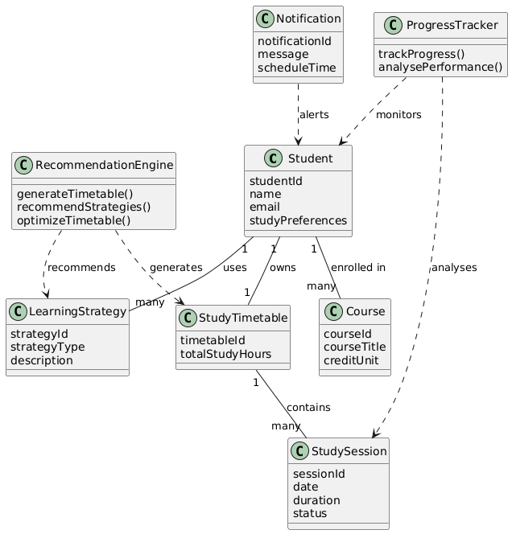

Figure 3.5: Class Diagram of the system

Sequence Diagram
The interaction between the student and the major system components like the user interface, the recommendation engine, study timetable module, progress tracker and the notification module are represented in Figure 3.6. The diagram shows the way the data related to learners is gathered, processed to create and optimize a personalized study schedule, and assisted by the progress tracking as well as the smart notifications, which reflect the adaptive and feedback based nature of the system.

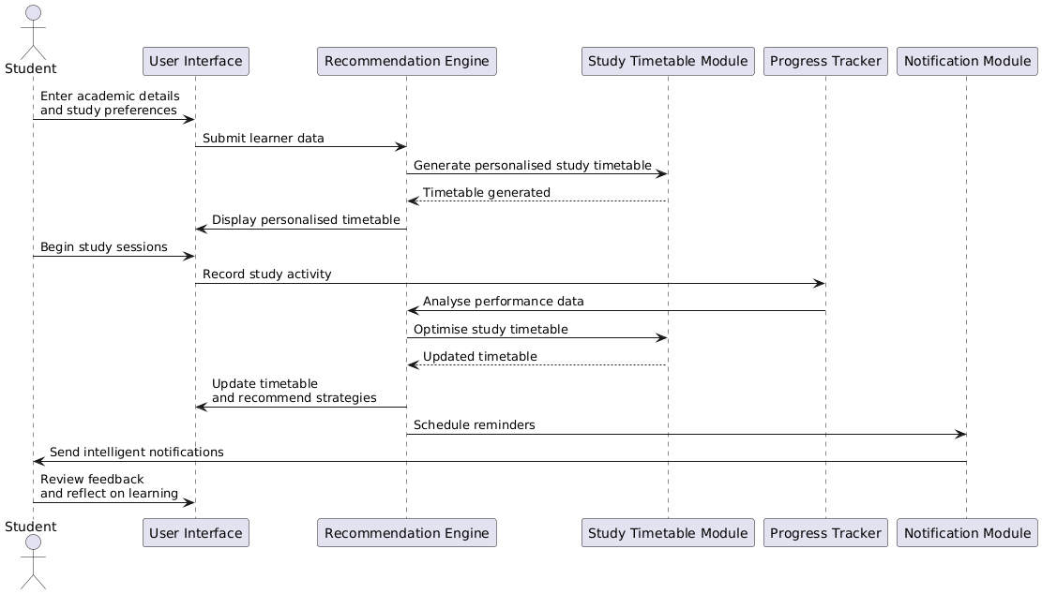

Figure 3.6: Sequence Diagram of the system

Activity Diagram
The two figures below demonstrate the activity diagrams of the proposed AI powered personalised study planning and learning recommendation system. The personalised study planning workflow is illustrated in Figure 3.7a which illustrates the way that student data is gathered and processed to create a custom learning schedule and prescribe the best learning strategies. Figure 3.7b shows the study monitoring and optimisation workflow where the data on the study activity and performance are monitored and analysed to decide whether some adjustments have to be made thus allowing the timetable to be optimised, the strategy to be updated, intelligent reminders and reflective learning support.

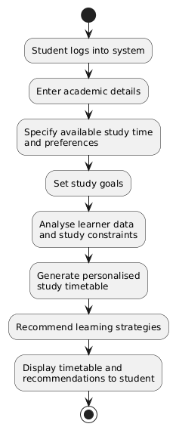
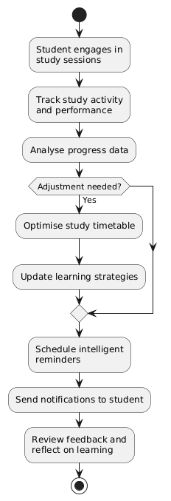

Figure 3.7a : Activity Diagram for Personalised Figure 3.7b: Activity Diagram for
Study Planning Workflow Study Monitoring &
Optimisation Workflow

Technological Stack
This section presents the technological stack for the development of the proposed system. It provides an overview of the technologies selected for the frontend, backend, database and additional tools.

Overview of Selected Technologies
The proposed system will take a mobile based, client-server architecture model that is aimed at providing personalised study planning and learning recommendation to the students. The mobile-first frontend interface allows students to use the system on a handheld device whereas a robust backend service can process and make informed decisions and integrate the system. The intelligence of the system is a combination of rule based reasoning with simple machine learning methods used to assist the adaptive management of the study timetable and recommending the learning strategies. Relational database management system is employed to uphold dependable storage of user information, educational records and learning analytics, as well as the support tools that contribute to the security and maintainability. Beyond the selected frontend, backend and database technologies, the proposed system also follows a structured artificial intelligence methodology to ensure that its intelligent functions are implemented in a measurable way. This methodology defines the workflow for learner data collection, training dataset preparation, feature engineering, model training, model testing and deployment for recommendation and timetable optimisation.

Frontend Technologies
- Next.js (React Framework): A React based framework employed to create the mobile-based user interface and mobile-first interface which is able to be responsive with an efficient interaction with backend services.
Features:
- Responsive Design: Enables the application to adapt to different mobile screen sizes and orientations.

- Component Based Architecture: Provides reusable user interface components.

- Client-Server Interaction: Communicates with the backend through APIs.

Backend Technologies
- Django (Python Web Framework): A Python framework used to implement the backend logic of the system.
- Django REST Framework (DRF): Used to expose backend functionalities as RESTful APIs.
- Rule-Based Recommendation Engine with scikit-learn (Python): A backend recommendation module implemented in Python that combines a rule based logic with basic machine learning techniques using the scikit-learn.
Features:
- Rule-Based Decision Logic: Applies rules and heuristics to allocate study time and recommend appropriate learning strategies.

- API Management: Supports data exchange between the frontend and backend through RESTful services.

- Adaptive Intelligence: Enables the system to analyse learner behaviour and performance data.

- Machine Learning Support: Utilises basic machine learning models provided by scikit-learn to identify patterns in study behaviour.

Database and Additional Tools
- PostgreSQL (Relational Database Management System): PostgreSQL is used as the primary database for the system to store student data.
- Authentication and Security (JWT with Django REST Framework): JSON Web Tokens (JWT) are used to implement secure authentication within the system. JWT based authentication ensures that only authorised users can access system functionalities.
- Version Control (Git and GitHub): Git is used for source code version control, while GitHub supports code management and project tracking.

AI Methodology and Model Development Process
This section presents the methodology for implementing the artificial intelligence component of the proposed AI-powered personalised study planning and learning recommendation system. The methodology explains how external educational interaction datasets are curated and mapped into project features, how prediction models are developed and evaluated and how model outputs are integrated into the application to support adaptive decision making.

AI Objectives and Prediction Tasks
The AI component of this study is designed to support two major tasks in line with the project objectives:
- Adherence prediction: The system estimates the likelihood that a student will follow through with planned study sessions.
- Learning strategy recommendation: The system suggests suitable strategy categories based on learner profile and study behaviour signals.
These two tasks support personalised timetable optimisation and targeted learning support.

Data Collection Strategy
Because pilot users cannot generate large and reliable behavioural data within the project timeline, this study adopts a secondary educational dataset strategy for model development. Data is sourced from established learning analytics repositories with longitudinal learner interaction events and performance outcomes then mapped into the project canonical features such as planned workload, actual effort, completion rate, help-seeking behaviour and consistency indicators. This external dataset supports initial training and benchmarking while live in-app logs are reserved for post-deployment domain adaptation and retraining.

Dataset Construction and Target Definition
A supervised learning dataset is constructed from mapped external learner interaction records. Each row represents a learner-window or study-session instance with engineered input features and associated target values. Typical input features include workload and effort proxies, completion patterns, behavioural stability, support-seeking frequency and recent performance indicators. Two target outputs are defined for modelling. The first target is adherence score which is represented as a continuous value between 0 and 1. A second optional target, strategy label, is defined for future supervised classification. It is not populated by the external training dataset and the production recommendation module operates rule-based until in-app strategy outcomes are available.

Data Preprocessing and Feature Engineering
The dataset is prepared through preprocessing operations to ensure quality and consistency. Missing numerical values are handled with median imputation while categorical values are handled with mode imputation. Categorical variables are transformed into machine readable encoding and behavioural trend features are derived from historical activity records. Dataset splitting is carried out in a time-aware and user-aware manner to reduce leakage and produce more realistic testing outcomes.

Model Selection and Training Procedure
The study adopts a two-stage intelligence strategy. First is a rule-based baseline implemented to provide stable and explainable initial recommendations. Second, machine learning models are trained to improve adaptivity and predictive performance. For adherence prediction, tree-based regression models such as Random Forest or Gradient Boosting are used. For strategy recommendation, a rule-based engine with a heuristic confidence score is used as the production module. A supervised classifier (Random Forest) is reserved for future work once sufficient in-app strategy-label data is available, as external training datasets do not carry validated strategy labels. Training is performed using a train-validation-test workflow with cross-validation and hyperparameter tuning before final model selection.

Model Testing and Evaluation Metrics
Model evaluation is performed using task-specific metrics. For adherence prediction, the metrics used are Mean Absolute Error (MAE), Root Mean Squared Error (RMSE) and R-squared (R2). For strategy recommendation, the metrics used are Accuracy, Precision, Recall and F1-score which is supported by the confusion matrix analysis. These metrics define the evaluation contract for the future supervised classifier, but the current rule-based engine is assessed qualitatively against expected strategy patterns. To validate the intelligence contribution of the system, machine learning outputs are compared against baseline rule based outputs.

Deployment, Monitoring and Retraining
After evaluation, selected models are exported as versioned model artifacts and integrated into backend inference services. During system operation, prediction logs and usage outcomes are monitored to detect performance degradation or behavioural drift. A rule based fallback mechanism is retained to maintain reliability where model inference is unavailable. Model retraining is carried out periodically or triggered when defined performance thresholds are not met.

Ethical and Reliability Considerations
The AI methodology of the proposed system follows key ethical and reliability requirements. User consent is required for data usage in analytics and model training. Training datasets are handled with privacy-aware procedures and minimum exposure of personally identifying information. Recommendation outputs are designed to be understandable and adjustable by users, thereby maintaining learner autonomy while supporting trust and responsible AI use in educational settings.

Chapter Four: Implementation

System Requirements
The system is a software project that uses Next.js client, Django REST API backend, a PostgreSQL database, and an adherence prediction model trained and loaded at inference time. Its requirements are framed as the minimum configuration of the hardware that is sufficient to install and operate the system, the software stack required for the system, and the interface and connectivity requirements that enable the components to work well together.

Hardware Requirements
This system is a client-server system; thus, there are two operating environments for the hardware requirements: the end-user device that accesses the web client, and the development/workstation upon which the back-end services and database are running.
The hardware requirements for the client device used to access the system are listed below:
- Personal computer or smartphone with a modern multi-core processor.
- A minimum of 2 GB of RAM to support the browser and the rendered interface.
- A minimum of 500 MB of free storage for the browser cache and downloaded resources.
- A display capable of rendering at a resolution of at least 360 by 640 pixels.
- A stable internet or local network connection sufficient to issue requests to the backend.

The hardware requirements for the development or hosting workstation used to run the backend and the database container are listed below:
- An x86_64 or ARM-based workstation with a multi-core processor.
- A minimum of 8 GB of RAM to run the backend, the PostgreSQL container, and the development tools concurrently.
- A minimum of 10 GB of free storage for source code, dependencies, the database volume and the trained model artifact.
A stable internet connection for the initial installation of dependencies and the pulling of container images.
The hardware requirements for the client device used to access the system are listed below:
- Personal computer or smartphone with a modern multi-core processor.
- A minimum of 2 GB of RAM to support the browser and the rendered interface.
- A minimum of 500 MB of free storage for the browser cache and downloaded resources.
- A display capable of rendering at a resolution of at least 360 by 640 pixels.
- A stable internet or local network connection sufficient to issue requests to the backend.

The hardware requirements for the development or hosting workstation used to run the backend and the database container are listed below:
- An x86_64 or ARM-based workstation with a multi-core processor.
- A minimum of 8 GB of RAM to run the backend, the PostgreSQL container, and the development tools concurrently.
- A minimum of 10 GB of free storage for source code, dependencies, the database volume and the trained model artifact.
- A stable internet connection for the initial installation of dependencies and the pulling of container images.

Software Requirements
The software stack is composed of the operating system, the runtimes for the backend and the frontend, the database, the web frameworks and the machine learning libraries used during inference. The following items are required:
- Operating system: Windows 10 or later, macOS 12 or later, or a recent Ubuntu Linux distribution.
- Python 3.12 or later, used to run the Django backend and the model inference service.
- Node.js 20 or later with the npm package manager, used to install and run the Next.js client.
- Docker Desktop or Docker Engine 24 or later, used to provision the PostgreSQL database container in development.
- PostgreSQL 16, provided through the Docker Compose service rather than installed natively.
- Django 5.0.7 with Django REST Framework 3.15.2 and djangorestframework-simplejwt 5.3.1 for backend services and authentication.
- Next.js 14.2.5 with React 18.3.1 for the frontend, alongside TypeScript 5.5.4 and the lucide-react icon library.
- Scikit-learn 1.5.1, pandas 2.2.2, numpy 1.26.4 and joblib 1.4.2 for the canonical dataset construction and the trained model artifact.
- A modern web browser such as Chrome, Edge, Firefox or Safari for accessing the client at http://localhost:3000.

Interface Requirements
The interface requirements describe the connectivity and access boundaries that allow the client, the backend and the database to communicate during local development and demonstration:
- TCP port 3000 must be available on the host machine for the Next.js development server.
- TCP port 8000 must be available on the host machine for the Django REST API server.
- TCP port 55432 must be available on the host machine for the PostgreSQL container exposed by Docker Compose.
- Outbound internet access is required during the initial installation of Python and Node.js dependencies and during the pulling of the PostgreSQL container image.
- Authenticated API access from the frontend to the backend is mediated by JSON Web Tokens issued by the authentication endpoint and stored in browser local storage.
- Only one human resource, the learner, is required to operate the system once the services are running.

System Execution/Output
This section presents the steps required to execute the system from a clean state and the user outputs that follow. Sections 4.2.1, 4.2.2 and 4.2.3 describe the bring-up of the database, the backend and the frontend respectively. Section 4.2.4 walks through each screen of the running system using screenshots captured from a seeded user account named ‘pilot_consistent’ which represents a learner with a high adherence pattern and is therefore well suited to demonstrate the analytical components of the system.

Bringing Up Dependencies
The system depends on a PostgreSQL database that is provisioned through Docker Compose. Before the backend can be started, the database container must be brought up and confirmed to be accepting connections on the configured port. The following commands are executed from the repository root:
- Run docker-compose up -d db to create and start the fyp_postgres container in detached mode using the configuration in docker-compose.yml.
- Run docker exec fyp_postgres pg_isready -U fyp_user -d fyp_db to confirm that the database is ready to accept connections on the exposed port 55432.

Backend Startup
Once the database is ready, the Django backend can be started. The first time the system is installed, the Python dependencies must be installed and the schema must be migrated to the database. The pilot dataset is then loaded so that the dashboard and the history views render with representative data for the demonstration.
Steps:
- Run pip install -r backend/requirements.txt to install the Python dependencies into the active environment.
- Run python manage.py migrate inside the backend directory to apply the database migrations.
- Run python manage.py seed_pilot_data inside the backend directory to seed the five deterministic pilot accounts and their plans, recommendations and session logs.
- Run python manage.py runserver 8000 inside the backend directory to start the Django development server on port 8000.

Frontend Setup
The Next.js frontend is started independently of the backend. The first time the system is installed, the Node.js dependencies must be installed. The development server is then started on port 3000 and serves the client interface.
Steps:
- Run npm install inside the frontend directory to install the Node.js dependencies declared in package.json.
- Run npm run dev inside the frontend directory to start the Next.js development server on port 3000.

System Output Walkthrough
Once the backend and the frontend are running, the application is accessed from a web browser at http://localhost:3000. The public landing page is the first screen rendered for an unauthenticated visitor and is shown in Figure 4.1. The page introduces the system, summarises its core capabilities through four cards and offers two entry points to the authentication screen through the Login and Create account buttons.
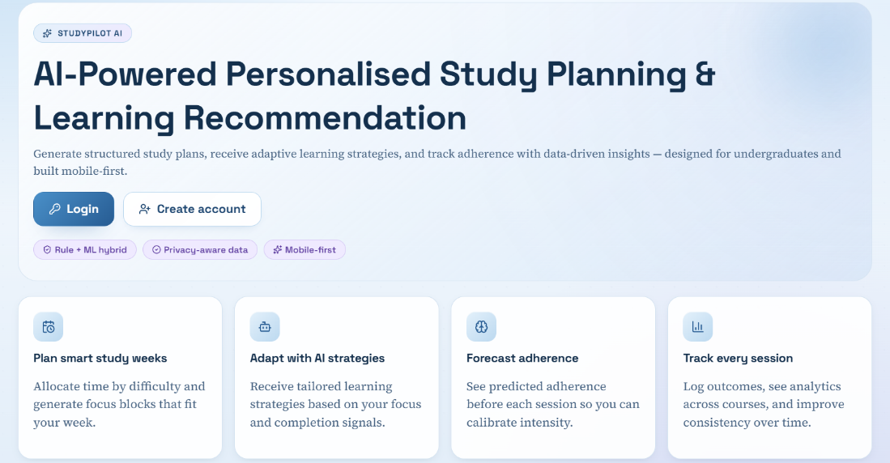
Figure 4.1: Landing page of the application.

Authentication
The learner's first interaction with the tool is at the authentication screen that was reached from the landing page. It is shown in Figure 4.2. The left card titled ‘Session access’ displays the registration form with the username, email and password box and three options: Register, Login and Clear session. The right card titled ‘What sits behind the login’ displays the components that are secured to the workspace once the learner is logged in: the JWT-secured workspace, the adherence model loaded into the workspace, the rule-based recommendation engine, and the persisted history. If the credentials are valid, the client receives a JSON Web Token from the backend, which the client stores in their local storage, and the client switches to the workspace overview. A workspace route guard component catches all protected routes and sends back to this authentication page all everyone who is not authenticated.

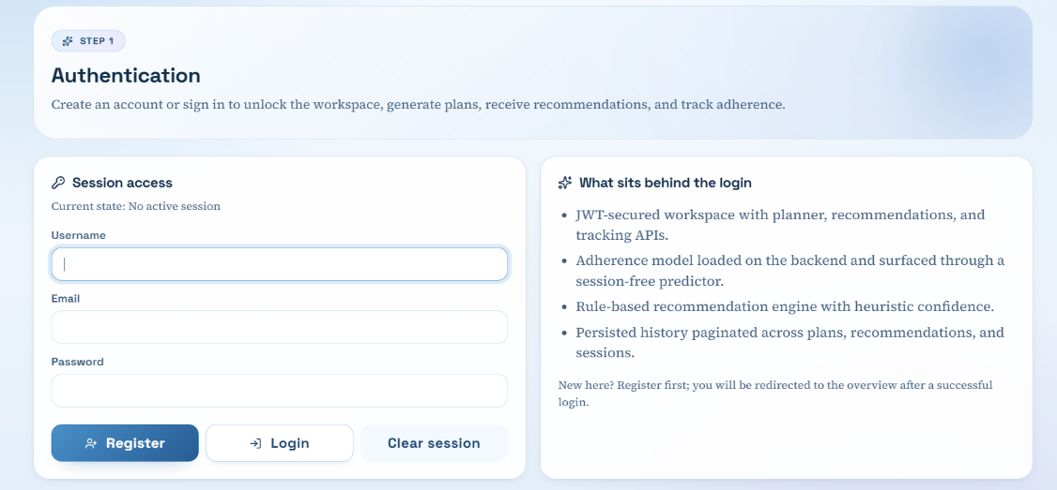

Figure 4.2: Authentication screen showing the session access form and the side panel describing the secured components behind the login.

Workspace Overview
After a successful login, the learner is taken to the workspace overview shown in Figure 4.3. The left side navigation panel shows the four workspace areas: Overview, Study Planner, Recommendations and Progress. The hero section restates the project title and frames the workspace as the place where the learner moves through the journey supported by the system. Two introduction cards are presented next: ‘Your quick start’, which lists the four numbered steps that a first-time learner should follow, and ‘What you gain’, which lists the four learning benefits the system targets. A grid of four navigation cards then links the learner to the Sign in, Build my timetable, Get AI strategies and Track and forecast areas of the workspace.
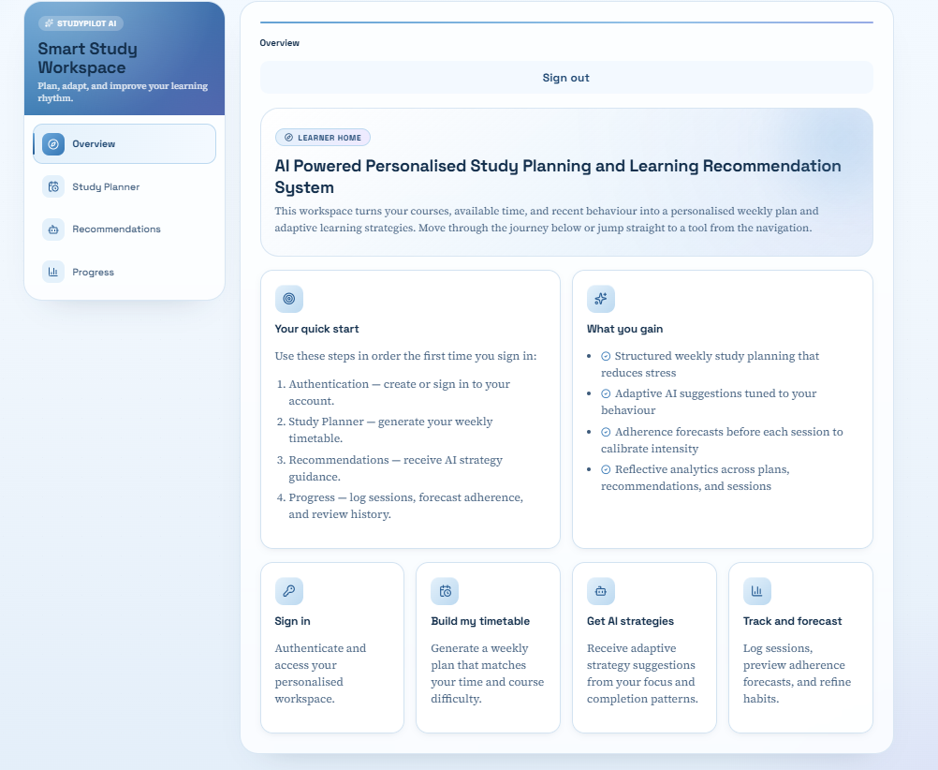
Figure 4.3: Workspace overview displayed immediately after a successful login.

Study Planner
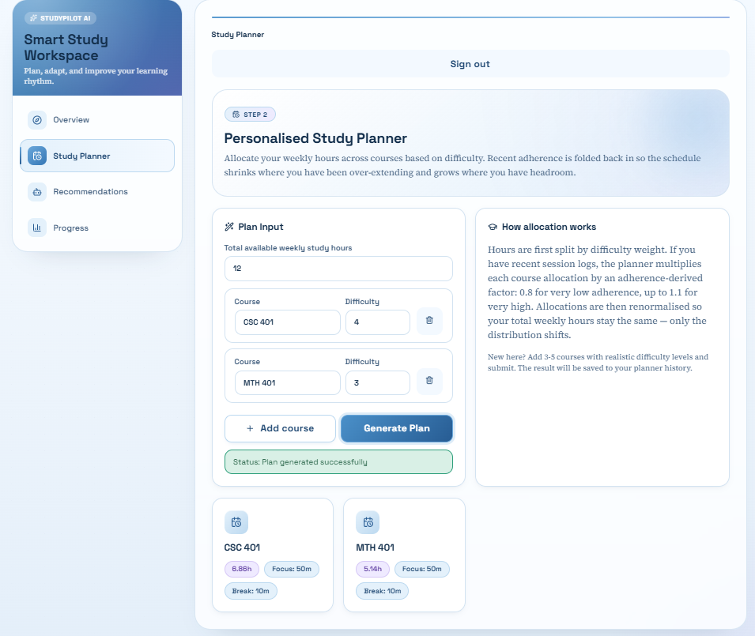
The Study Planner is reached from the side navigation panel. The screen is shown in Figure 4.4 with a generated plan for the learner. The ‘Plan Input’ card on the left collects the total available weekly study hours and a list of courses each with a name and a difficulty rating between one and five. In the captured run, twelve hours were specified for the week with two courses, CSC 401 at difficulty four and MTH 401 at difficulty two. After the learner submits the form, the rule-based allocation in the backend distributes the hours in proportion to the difficulty of the courses and then rescales each course by an adherence-derived factor computed from the learner's recent session logs over the last thirty days. The adjusted allocations are returned and rendered as per-course cards at the bottom of the screen with the allocated hours, the focus block length and the break length. The plan is also persisted in the planner history and becomes available on the ‘Progress page’. The ‘How allocation works’ card on the right summarises the adherence-derived factors used by the planner so that the learner can interpret the result.

Figure 4.4: Study Planner page after submitting a plan request for twelve weekly study hours across two courses.

Recommendations
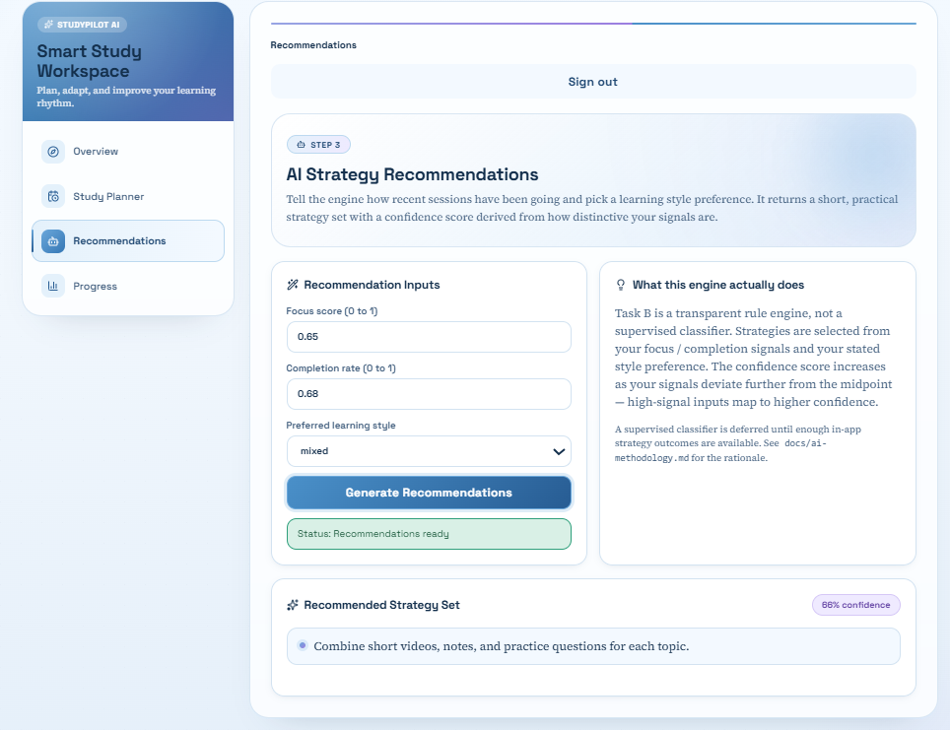
The Recommendations screen is shown in Figure 4.5. The ‘Recommendation Inputs’ card on the left collects the focus score, completion rate, and learner's preferred learning style from a select control offering visual, reading, practice and mixed. In the captured run, the inputs were a focus score of 0.65, a completion rate of 0.68 and the mixed preferred style. After submission, the rule engine in the backend selects an appropriate set of strategies based on the supplied signals and produces a heuristic confidence score that increases as the focus and completion inputs deviate further from the neutral midpoint of 0.5. The result is returned as the ‘Recommended Strategy Set’ card at the bottom of the screen with the confidence value shown in the top right pill and the strategy items listed below. The ‘What this engine actually does’ card on the right explains that the recommendation module is implemented as a transparent rule engine rather than as a supervised classifier and that supervised classification is reserved for future work.

Figure 4.5: Recommendations page returning a strategy set and a confidence value for the supplied behavioural inputs.

Progress - Overview Tab
The Progress page is reached from the side navigation panel and is split into four sub-routes: Overview, Log Session, Predictor and History. The Overview tab is the default landing tab and is shown in Figure 4.6 for the pilot_consistent account. The hero section summarises the state of the learner's workspace, displaying the total number of logged sessions, plans and recommendation events, and the active model version. Four key analytics tiles are presented below: the average adherence aggregated across all logged sessions, the average AI forecast averaged across the predicted adherence values stored with each session log, the average focus and completion signals and the time coverage given as the cumulative actual minutes divided by the cumulative planned minutes. The ‘Course Spotlight’ card identifies the course with the most logged sessions and reports the weekly intensity and the difficulty mix of the training dataset snapshot. The ‘Recent Sessions’ card lists the five most recent session logs with the adherence, predicted adherence and model version, and the ‘Latest Recommendation’ card shows the most recent recommendation event with its strategy and confidence.
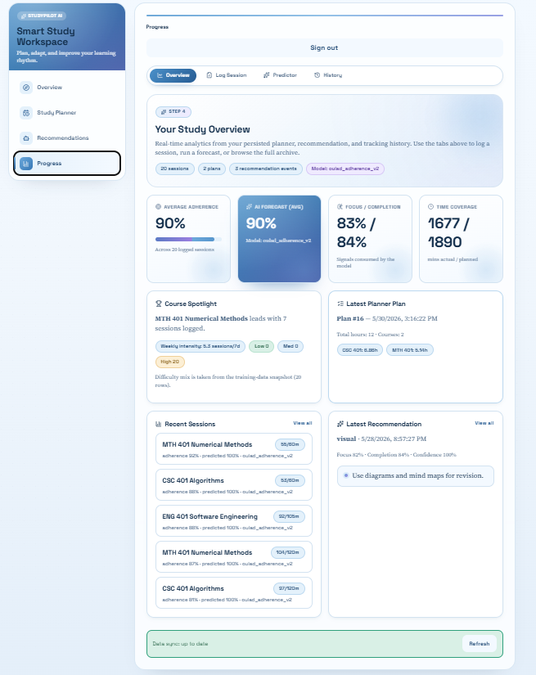
Figure 4.6: Progress overview tab displaying the four key analytics tiles, the course spotlight, the most recent sessions, the latest plan and the latest recommendation.

Progress - Log Session Tab
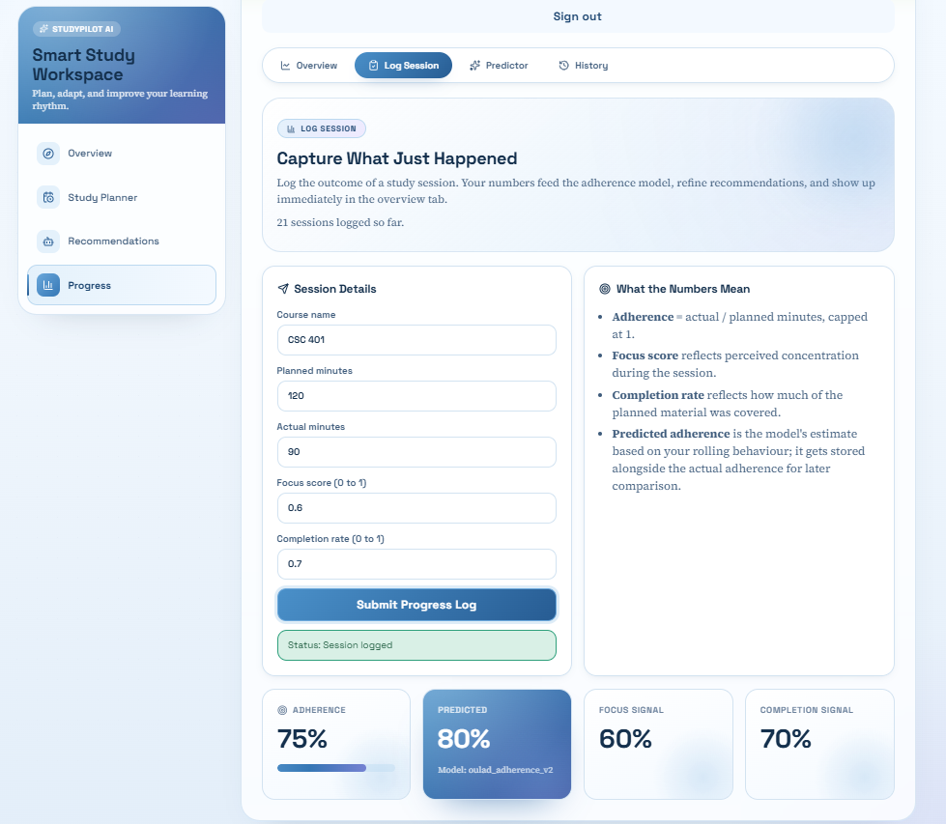
The ‘Log Session’ tab of the Progress page is shown in Figure 4.7. The ‘Session Details’ card on the left collects the course name, planned minutes, actual minutes, focus score and completion rate for a single study session. The ‘What the Numbers Mean’ card on the right summarises the meaning of each input so that the learner understands how to score the session. In the captured run, the inputs were CSC 401 with one hundred and twenty planned minutes, ninety actual minutes, a focus score of 0.60 and a completion rate of 0.70. When the form is submitted, the backend computes the adherence score as the actual minutes over the planned minutes, runs the adherence model on the rolling features to obtain a predicted adherence value and a model version label, persists the row in the session log table, then returns the four metrics that are then rendered as the tiles at the bottom of the screen. The ‘Predicted’ tile displays the model version label so that the learner is aware that the figure was produced by the deployed oulad_adherence_v2 artifact.

Figure 4.7: Progress log session tab after submitting a study session, with the adherence, predicted adherence, focus signal and completion signal tiles updated.

Progress - Predictor Tab
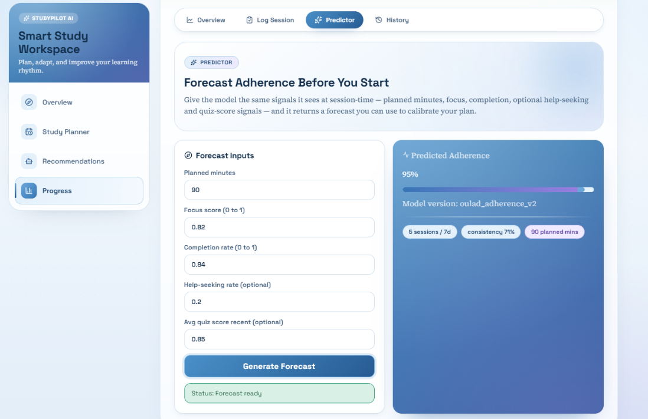
The ‘Predictor’ tab of the Progress page is shown in Figure 4.8. The ‘Forecast Inputs’ card on the left collects the planned minutes for an upcoming study block, focus score, completion rate and two optional behavioural signals: the help-seeking rate and average recent quiz score. The card on the right displays the resulting prediction once the form has been submitted. In the captured run, the planned minutes was set to ninety, focus and completion values matched the seeded profile of the pilot_consistent account and the model returned a predicted adherence of ninety-five per cent. The forecast card displays the predicted value, the active model version and a row of pills summarising the rolling features used by the prediction: the number of sessions in the last seven days, consistency score derived from that count and planned minutes that was supplied. Unlike the ‘Log Session’ tab, the ‘Predictor’ tab does not hold on to any record and does not consume actual minutes, allowing the learner to calibrate a planned session before it begins.
Figure 4.8: Progress predictor tab returning an adherence forecast for the supplied planned-session inputs.

Progress - History Tab
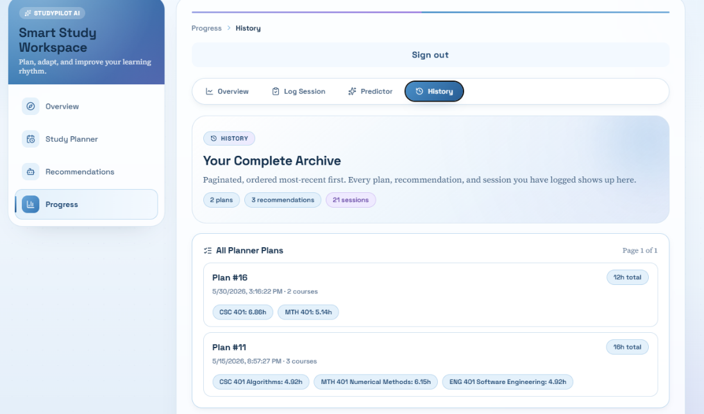
The ‘History’ tab of the Progress page provides the complete archive of the learner's persisted plans, recommendations and session logs. The top of the page is shown in Figure 4.9 and presents the hero with the total counts of each type of record, followed by the ‘All Planner Plans’ card listing the plans most recent first with the plan identifier, creation timestamp, number of courses and the per-course allocations. The continuation of the page is shown in Figure 4.10 and presents the ‘All Recommendation Events’ card with each recommendation showing its preferred style, focus, completion, confidence and strategy items, followed by the ‘All Session Logs’ card with each session showing the course, actual and planned minutes, adherence, predicted adherence and model version. Each card uses an independent pagination control with a page size of six items, allowing the learner to navigate large histories without overwhelming the page.

Figure 4.9: Progress history tab showing the paginated list of planner plans.
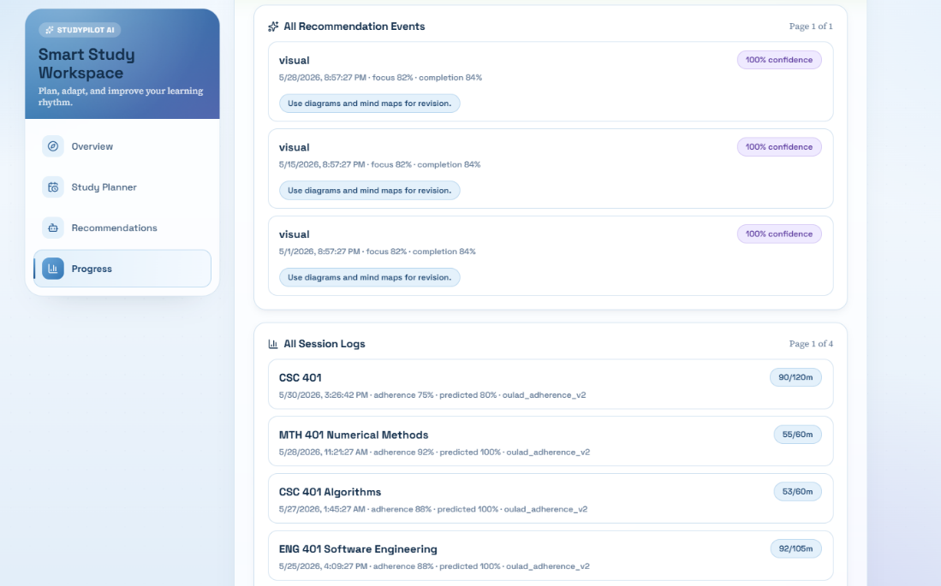
Figure 4.10: Progress history tab continued, showing the paginated recommendation events and session logs.

System Evaluation
This section shows the evaluation of the developed system to the 3rd research objective to evaluate system ease of use, learning effectiveness, and study efficiency with evaluation metrics and user feedback. The aspect that was evaluated as the operational measure of ease of use was perceived usability which was measured using the validated instrument (System Usability Scale – SUS) and administered to a sample of undergraduate students. The methodology, participants and procedure, results, and discussion are presented in turn.

Evaluation Methodology
The System Usability Scale was chosen as the main usability measure in this assessment. The SUS was originally created by Brooke (1996) and is widely used in software and digital service evaluation. The instrument is made of 10 statements that are both positively and negatively formulated and are rated by the respondents on a 5-point Likert scale from 1 (agree strongly) to 5 (disagree strongly). The ten items administered in this study are listed below in the standard order:
- I think that I would like to use this system frequently.
- I found the system unnecessarily complex.
- I thought the system was easy to use.
- I think that I would need the support of a technical person to be able to use this system.
- I found the various functions in this system were well integrated.
- I thought there was too much inconsistency in this system.
- I would imagine that most people would learn to use this system very quickly.
- I found the system very cumbersome to use.
- I felt very confident using the system.
- I needed to learn a lot of things before I could get going with this system.
Responses to the raw five points are converted into a 0-100 SUS score following the standard scoring method. Each odd numbered item (1, 3, 5, 7 and 9) has a contribution to the score, the raw response minus one. The contribution to the score for each even numbered item (2, 4, 6, 8 and 10) is made as follows: 5 minus the raw response. The contributions are added up to get a value ranging from 0 to 40; this value is then multiplied by 2.5 to obtain a final value between 0 and 100 that represents the SUS score. The headline result is the mean SUS score obtained by all participants. Sauro and Lewis (2016) have established benchmarks for perceived usability: For a score above about 68 perceived usability is above average, for a score in grade B (71.1 to 80.7) perceived usability is good, and for a score in grade A (80.8 to 84.0) perceived usability is excellent, with scores in grade A+ (above 84.1) being best imaginable.

Participants and Procedure
Evaluation was done in person on the researcher's development workstation, with a full implementation of the system running on localhost. The participants were all directly connected with the system on the researcher's machine, and completed the SUS questionnaire on a second machine via a Google Form, where the answers were collected anonymously. To make the responses comparable, the same sequence of sessions was followed for all the participants.
Eleven undergraduate students participated in the evaluation, which was done in a convenience sample. The recruitment was directed at the population the system is intended for–students at Pan-Atlantic University undergraduate students–with a focus on breaking down the population by years of study and prior exposure to digital study planning applications. All participants expressed informed verbal consent to participate and had the option to end participation at any time during the session. The composition of the participants in the background is summarised in Chapter 4.3.3.
To eliminate protocol differences as a source of bias in the scores, the wording and order of steps were the same for all participants. The following steps were used for each session:
- The participant was briefed on the purpose of the evaluation and reassured that the system, not the participant, was being assessed.
- The participant created an account and signed in to the workspace.
- The participant generated a weekly study plan for twelve total hours across two self-chosen courses with self-chosen difficulty values.
- The participant requested a learning strategy recommendation using a scripted scenario of average focus and approximately half completion.
- The participant used the predictor tab to forecast adherence for a ninety-minute planned session.
- The participant logged a completed study session with self-chosen focus and completion values and reviewed the resulting analytics tiles.
- The participant browsed the history tab to view the persisted records.
- The participant completed the ten-item SUS questionnaire on the secondary device.
Each full session lasted between twelve and eighteen minutes. After every session the researcher reset the workspace state by signing out the participant's account and clearing the browser session so that the next participant started from an identical clean baseline. The raw response data was exported from Google Forms as a CSV file and processed using the `score_sus.py` script in `docs/evaluation/`.

Results and Analysis
Eleven undergraduate participants completed the evaluation. The aggregated SUS results across the sample are summarised in Table 4.1, the distribution of individual scores is presented in Figure 4.11, and the per-item interpretation is reported in Chapter 4.3.5.
The headline SUS score for the system is 61.82 with a standard deviation of 12.45. According to the benchmarks of Sauro and Lewis (2016), this places the system in Grade C (51.7 to 71.0), corresponding to a usability rating of OK or marginal, with the result sitting approximately six points below the established industry-average SUS score of 68. One participant returned an A+ rating (84.1 or above), eight participants returned scores in the C band, and two participants returned scores in the D band (39.0 to 51.6).

Table 4.1: Aggregated SUS results across eleven participants.
Metric | Value
Participants (n) | 11
Mean SUS score | 61.82
Median SUS score | 62.50
Standard deviation | 12.45
Minimum score | 45.00
Maximum score | 90.00
Mean grade band | C (OK)
Above industry average (>=68) | 1 of 11
A+ grade count | 1
A grade count | 0
B grade count | 0
C grade count | 8
D grade count | 2
F grade count | 0

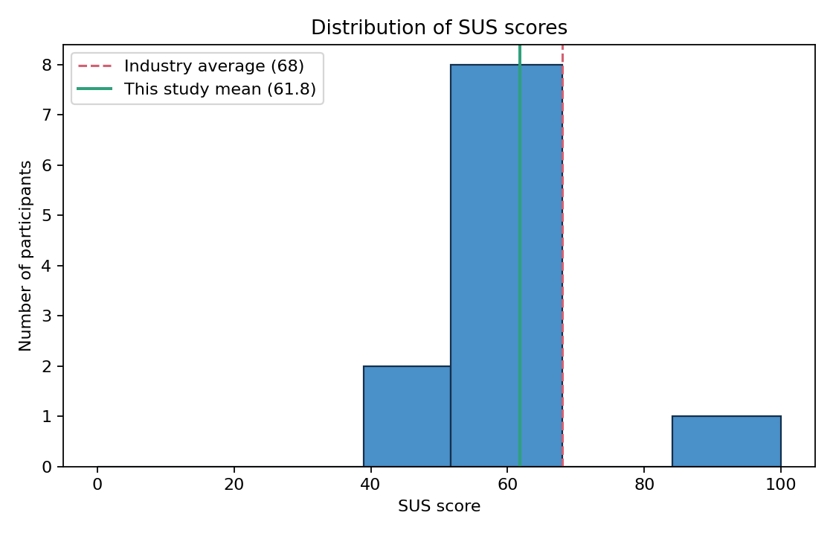
Figure 4.11: Distribution of System Usability Scale scores across the eleven participants, with the dashed line marking the industry-average score of 68 and the solid line marking the mean score recorded in this study.

Adherence Model Performance Metrics
In addition to the user feedback part of the evaluation, the third research objective also needs to be evaluated by quantifiable evaluation metrics of the system. The adherence prediction model is the main intelligent function of the system and the offline performance indicators are the quantitative evidence demonstrating that, the learning support provided by the system allows for a more accurate prediction of adherence than that of humans in the absence of machine learning. All of the metrics below were generated by the training pipeline in the `backend/ml/ directory and were contained in the full evaluation report, located at ‘docs/evaluation-report.md’.
The adherence model was trained on a canonical dataset of 200,000 learner-window rows from the Open University Learning Analytics Dataset loaded into the project canonical schema. Hyperparameters were selected over three different configurations of Random Forest using the validation split, and the best model was refitted using only the training and validation split for final evaluation, giving the following data splits: 70 per cent training data, 10 per cent validation data, and 20 per cent test data.
The Mean Absolute Error (MAE), Root Mean Squared Error (RMSE) and coefficient of determination (R-squared) were used as three regression metrics. A mean-prediction baseline was created by generating the mean of the target of the training set for each test row, which is the baseline any useful model should surpass. Table 4.2 compares the two and Figure 4.12 shows a graph of them.
Table 4.2: Mean Absolute Error, Root Mean Squared Error and R-squared for the mean-prediction baseline and the trained Random Forest model on the held-out test set.
Metric | Mean-prediction baseline | Trained Random Forest
MAE | 0.3122 | 0.0291
RMSE | 0.3408 | 0.0709
R-squared | -0.0036 | 0.9566

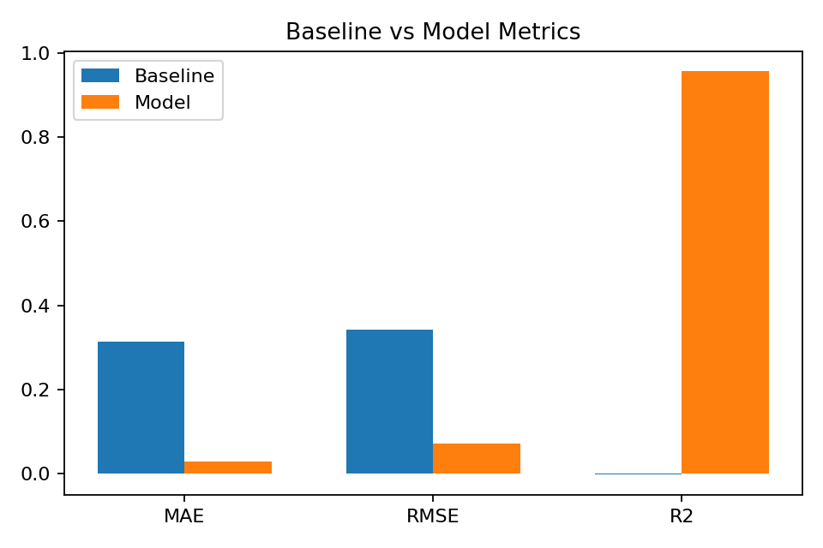
Figure 4.12: Comparison of error metrics for the mean-prediction baseline and the trained Random Forest adherence model on the held-out test set.

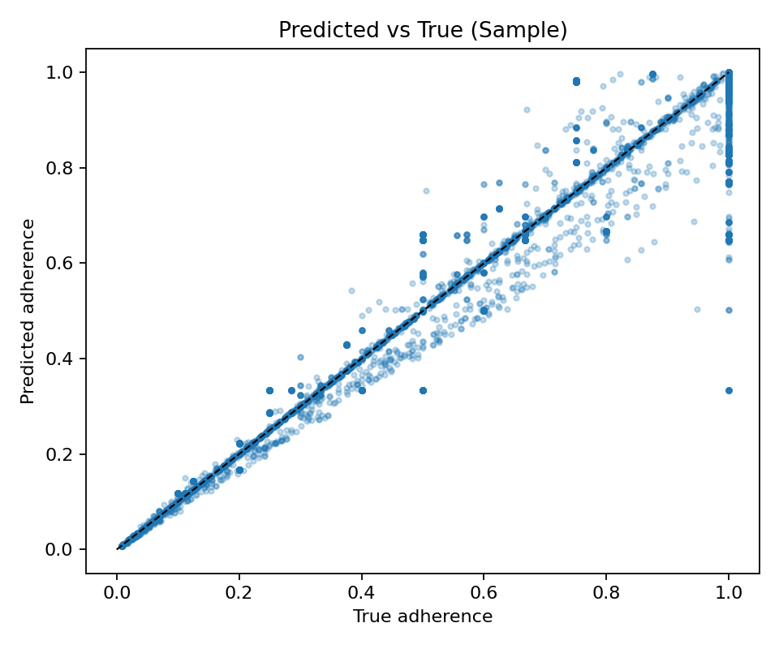
The trained Random Forest model produced a Mean Absolute Error approximately one order of magnitude lower than the baseline (0.0291 against 0.3122) and an R-squared of 0.9566 against an effectively zero baseline R-squared of -0.0036. The improvement is shown graphically in Figure 4.12. The predicted-versus-true scatter in Figure 4.13 confirms that the predictions track the true adherence values closely across the full range of the target. The residuals histogram in Figure 4.14 confirms that the prediction errors are tightly distributed around zero, with no obvious skew or systematic bias.
Figure 4.13: Predicted adherence values plotted against the true adherence values for a sampled subset of the held-out test set.

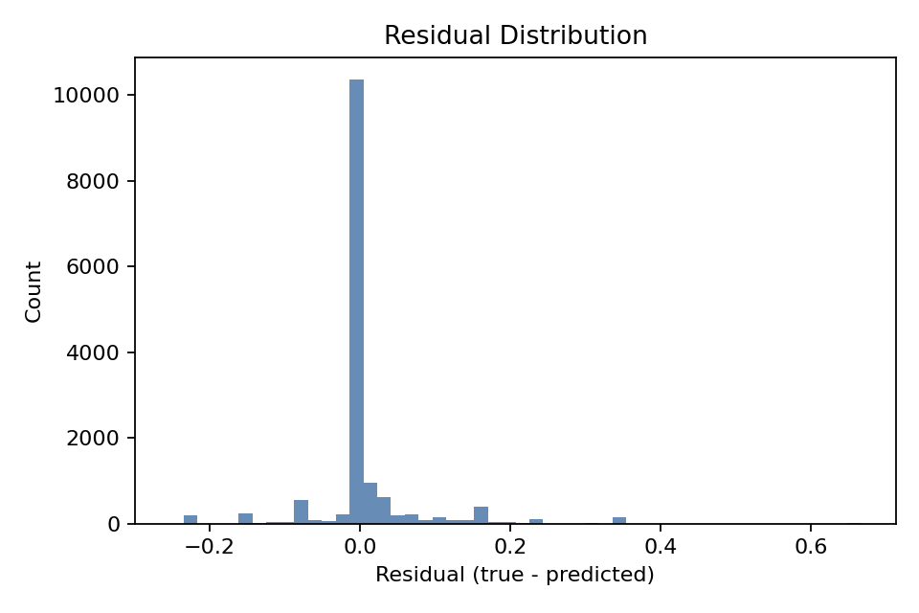
Figure 4.14: Distribution of the residuals (true adherence minus predicted adherence) for the held-out test set.

The feature importance values produced by the trained model are shown in Figure 4.15. The focus_score feature accounted for approximately 67 per cent of the model's predictive signal, followed by planned_minutes at approximately 15 per cent and the consistency and weekly-intensity features at approximately 9 per cent each. The completion_rate feature registered almost zero importance after the target-leakage discovery and the subsequent data-construction fix documented in the evaluation report, confirming that the model is no longer reading the answer from a leaked feature.

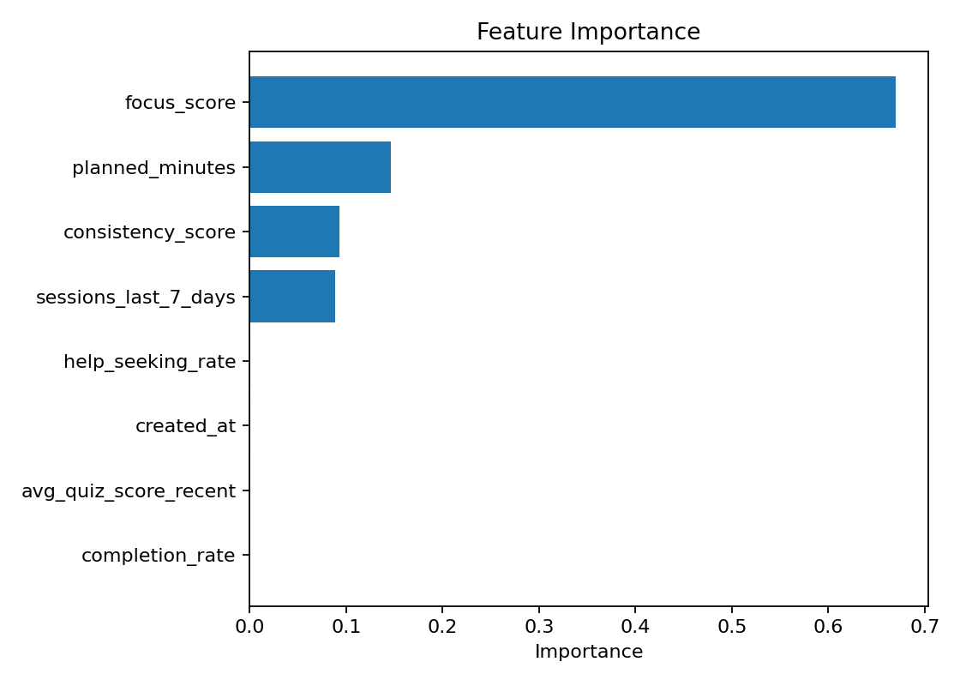
Figure 4.15: Feature importance values produced by the trained Random Forest adherence model, with completion_rate near zero confirming that the target-leakage issue identified during construction was resolved.

Residual-correlation disclosure is applicable to these metrics. The focus_score, planned_minutes and adherence_score features are all based on the OULAD click stream, and the leakage between the features completion_rate and adherence_score has been closed, but the remaining click features are inherently correlated with the target. This is a natural property of behavioural-proxy modelling when based on a click data set, and can only be partially removed. This residual correlation will be mitigated through the use of in-app signals collected and documented in the runtime schema, which will be used in future training cycles.

Discussion
The discussion interprets the findings of both parts of the assessment (SUS ratings and adherence model metrics) with regard to the third objective of the research and determines what the evidence shows as strengths and weaknesses in usability.
The SUS evaluation rate is 61.82 which is in Grade C and about 6 points lower than the overall industry rate of 68. The pattern of strengths and weaknesses detected by examination of per item converted scores is coherent. The system had the highest mean ratings on the items with a perceived ease of use (3.00 out of 4 possible ratings), perceived consistency (2.91 out of 4 possible ratings, where a higher value for the converted mean indicates that the participants did not experience the system as inconsistent), and integration of functions (2.82 out of 4 possible ratings).
The system was weakest on Item 10 - respondent required to learn a great deal before starting to use the system, with a score of 1.27 out of 4. This found significant consensus across participants, with Items 1 and 4 (both with 2.18) both reinforcing the same message that participants did not anticipate using the system often and felt that technical support would assist them in using it. Overall, these three smallest components indicate that there is an onboarding problem, not complexity with the interface.
The adherence model metrics complement the learning effectiveness and study efficiency aspects of the third research objective. The trained Random Forest has a Mean Absolute Error that is about one order of magnitude less than mean-prediction alone, and the predictions are directly used in the planner's adherence-weighted allocation factor. The quantitative evidence of the intelligent component's effect on the efficiency of the study is a system that can predict adherence with this degree of accuracy, compared to the accuracy that a rule-only approach would provide. The inherent methodological quality of the metric is enhanced by detection of the targets and subsequent construction fixes of the data, which yielded the more respectable R-squared of 0.9566 (compared to the spurious R-squared of 0.994 reported in the pre-fix model).
Altogether, the SUS directly addresses the "ease of use" part of the 3rd research question. Adherence model metrics offer quantitative evaluation evidence for the learning effectiveness and study efficiency components. The overall assessment shows that the intelligent backend of the system is suitable to meet the modelling goal, and the front-end onboarding process needs to be gated by the plan-first workflow suggested in Chapter Five. The evaluation also recognizes a number of limitations: the SUS sample of 11 participants is below the recommended range for stable estimates, the in-person single-session protocol does not provide any information about changes in behavior over time and qualitative learning-effectiveness measures were not gathered over the multi-week time frame recommended for the next evaluation cycle in Chapter Five.

Chapter Five: Summary, Conclusion and Recommendations

Summary
The present project was designed to fill the gap in personalised study planning with support from AI for undergraduate students. In order to do this, StudyPilot AI has been constructed as a mobile-first web application, featuring an AI trained adherence prediction model, a Django REST Framework backend, a PostgreSQL database, and a Next.js client. System collects study hours, course difficulty values and behavioural signals for each learner, generates an adherence adjusted weekly timetable, supports the learner with study strategies with a rule-based engine that uses heuristic confidence, and generates session logs to drive adherence feedback for future plans. Real-time forecasts are displayed in the user interface using an adherence prediction model, which has been trained with a canonical schema generated from the Open University Learning Analytics Dataset. Real-time forecasts are shown in the user interface through the use of an adherence prediction model trained on a canonical schema generated from the Open University Learning Analytics Dataset.
However, one of the drawbacks of the system is that there is no plan-first workflow gate. Users can log sessions and use the predictor and request recommendations before there is even a study plan in place, as revealed by the System Usability Scale evaluation as an onboarding shortcoming. The average SUS score from 11 participants was 61.82 in the Grade C range.

Conclusion
Finally, it can be concluded that the developed system achieves the goal of providing personalised study planning with the support of AI for undergraduate students. StudyPilot AI brings a combination of rule-based reasoning, a trained machine learning model and a clean interface to create a working platform that provides measurably improved adherence predictions over a non-intelligent baseline (0.3122 vs 0.0291 mean absolute error on a separate test set), bringing together the planning, recommendation and tracking modules into one integrated workspace.

Recommendation
While the current iteration of StudyPilot AI is functional, the following improvements would extend its potential:
- Plan-first workflow gate: requiring at least one active study plan before the log-session, predictor and recommendation modules become reachable would address the onboarding deficit identified by the SUS evaluation.
- Course autocomplete: replacing the free-text course-name input with a dropdown sourced from the active plan would eliminate the silent name-mismatch errors that currently break the adherence-factor lookup.
- Supervised strategy classifier: once sufficient in-app strategy outcome data has been collected, training a supervised classifier would replace the current rule engine with a learned recommendation model.
- Cloud deployment: hosting the system in a production environment would allow future evaluations and demonstrations to reach a broader participant pool and would let real learner-usage data accumulate for domain adaptation.
- Calendar integration and reminders: connecting the planner output to the learner's existing calendar and sending timely reminders for scheduled study sessions would remove the need for the learner to consult the planner on a separate screen.
By addressing these recommendations, StudyPilot AI can become a more polished and broadly useful tool for supporting personalised study planning across higher education.

References
Borchers, C., Fleischer, H., Yaron, D. J., McLaren, B. M., Scheiter, K., Aleven, V., & Schanze, S. (2025). Problem-Solving Strategies in Stoichiometry Across Two Intelligent Tutoring Systems: A Cross-National Study. Journal of Science Education and Technology, 34(2), 384-400.
Boroowa, A., & Herodotou, C. (2022). Learning analytics in open and distance higher education: The case of the Open University UK. In Learning analytics in open and distributed learning: Potential and challenges (pp. 47-62). Singapore: Springer Nature Singapore.

Broadbent, J., & Poon, W. L. (2015). Self-regulated learning strategies and academic achievement in online higher education learning environments: A systematic review. The Internet and Higher Education, 27, 1-13.

Broadbent, J. (2017). Comparing online and blended learners’ self-regulated learning strategies and academic performance. The Internet and Higher Education, 33, 24–32.

Brooke, J. (1996). SUS: A quick and dirty usability scale. In P. W. Jordan, B. Thomas, B. A. Weerdmeester, & A. L. McClelland (Eds.), Usability evaluation in industry (pp. 189–194). Taylor & Francis.

Chu, H. C., Hwang, G. H., Tu, Y. F., & Yang, K. H. (2022). Roles and research trends of artificial intelligence in higher education: A systematic review of the top 50 most-cited articles. Australasian Journal of Educational Technology, 38(3), 22-42.

Drachsler, H., & Greller, W. (2016, April). Privacy and analytics: it's a DELICATE issue a checklist for trusted learning analytics. In Proceedings of the sixth international conference on learning analytics & knowledge (pp. 89-98).

Hattie, L. D., Sahlberg, C. W., & Comer, P. P. (2023). Impact of mobile learning apps on study habits and academic performance of college students in the United States: A review of literature. Journal of Education, 6(3), 13-22.

Herodotou, C., Carr, J., Shrestha, S., Comfort, C., Bayer, V., Maguire, C., ... & Fernandez, M. (2025, March). Prescriptive analytics motivating distance learning students to take remedial action: A case study of a student-facing dashboard. In Proceedings of the 15th International Learning Analytics and Knowledge Conference (pp. 306-316).

Hlosta, M., Herodotou, C., Papathoma, T., Gillespie, A., & Bergamin, P. (2022). Predictive learning analytics in online education: A deeper understanding through explaining algorithmic errors. Computers and Education: Artificial Intelligence, 3, 100108.

Huang, J., Cai, Y., Lv, Z., Huang, Y., & Zheng, X. L. (2024). Toward self-regulated learning: effects of different types of data-driven feedback on pupils’ mathematics word problem-solving performance. Frontiers in Psychology, 15, 1356852.

Ifenthaler, D., & Yau, J. Y. K. (2020). Utilising learning analytics to support study success in higher education: a systematic review. Educational Technology Research and Development, 68(4), 1961-1990.

Jansen, R. S., Van Leeuwen, A., Janssen, J., Jak, S., & Kester, L. (2019). Self-regulated learning partially mediates the effect of self-regulated learning interventions on achievement in higher education: A meta-analysis. Educational Research Review, 28, 100292.

Kim, J., Merrill, K., Xu, K., & Sellnow, D. D. (2020). My teacher is a machine: Understanding students’ perceptions of AI teaching assistants in online education. International Journal of Human–Computer Interaction, 36(20), 1902-1911.

Lai, C. H., Jong, B. S., Hsia, Y. T., & Lin, T. W. (2020). Using reminder tools to increase learning motivation: A comparison of mobile devices, email and e-learning platforms.

Lim, L. A., Gentili, S., Pardo, A., Kovanović, V., Whitelock-Wainwright, A., Gašević, D., & Dawson, S. (2021). What changes, and for whom? A study of the impact of learning analytics-based process feedback in a large course. Learning and Instruction, 72, 101202.

Luckin, R., & Holmes, W. (2016). Intelligence unleashed: An argument for AI in education.

Matcha, W., Gašević, D., Uzir, N. A. A., Jovanović, J., & Pardo, A. (2019, March). Analytics of learning strategies: Associations with academic performance and feedback. In Proceedings of the 9th international conference on learning analytics & knowledge (pp. 461-470).

Miao, F., & Holmes, W. (2021). Artificial intelligence and education: Guidance for policy-makers.

Molenaar, I., de Mooij, S., Azevedo, R., Bannert, M., Järvelä, S., & Gašević, D. (2023). Measuring self-regulated learning and the role of AI: Five years of research using multimodal multichannel data. Computers in Human Behavior, 139, 107540.

Nagashima, T., Tseng, S., Ling, E., Bartel, A. N., Vest, N. A., Silla, E. M., ... & Aleven, V. (2022, June). Students’ self-regulated use of diagrams in a choice-based Intelligent Tutoring System. In Proceedings of the 16th International Conference of the Learning Sciences, ICLS 2022.

Nobbe, L., Breitwieser, J., Biedermann, D., & Brod, G. (2024). Smartphone-based study reminders can be a double-edged sword. npj Science of Learning, 9(1), 40.

Oulasvirta, A., Rattenbury, T., Ma, L., & Raita, E. (2012). Habits make smartphone use more pervasive. Personal and Ubiquitous Computing, 16(1), 105–114.

Ouyang, Z. (2025). Self-regulated learning and engagement as serial mediators between AI-driven adaptive learning platform characteristics and educational quality: a psychological mechanism analysis. Frontiers in Psychology, 16, 1646469.

Panadero, E. (2017). A review of self-regulated learning: Six models and four directions for research. Frontiers in Psychology, 8, 422.

Sauro, J., & Lewis, J. R. (2016). Quantifying the user experience: Practical statistics for user research (2nd ed.). Morgan Kaufmann.

Schraw, G., Crippen, K. J., & Hartley, K. (2006). Promoting self-regulation in science education: Metacognition as part of a broader perspective on learning. Research in Science Education, 36(1–2), 111–139.

Sedrakyan, G., Malmberg, J., Verbert, K., Järvelä, S., & Kirschner, P. A. (2020). Linking learning behavior analytics and learning science concepts: Designing a learning analytics dashboard for feedback to support learning regulation. Computers in Human Behavior, 107, 105512.

Sousa, E. B. D., Alexandre, B., Ferreira Mello, R., Pontual Falcão, T., Vesin, B., & Gašević, D. (2021). Applications of learning analytics in high schools: A systematic literature review. Frontiers in Artificial Intelligence, 4, 737891.

Stinar, F., Lee, H., Belitz, C., Nasiar, N., Fancsali, S. E., Ritter, S., ... & Bosch, N. (2025). Fairness of Bayesian Knowledge Tracing for Math Learners of Different Reading Ability. International Educational Data Mining Society.

Tang, K. H. D. (2024). Implications of artificial intelligence for teaching and learning. Acta Pedagogia Asiana, 3(2), 65-79.

Viberg, O., Hatakka, M., Bälter, O., & Mavroudi, A. (2018). The current landscape of learning analytics in higher education. Computers in Human Behavior, 89, 98-110.

Wu, X. Y., Ng, D. T. K., & Chiu, T. K. (2026). Self-Regulated Learning with AI: A Comparative Analysis of General-Purpose and Task-Specific Platforms. International Journal of Technology in Education, 9(1), 279-302.

Zimmerman, B. J., & Schunk, D. H. (2011). Self-regulated learning and performance: An introduction and an overview. Handbook of self-regulation of learning and performance, 15-26.

Zimmerman, B. J. (2002). Becoming a self-regulated learner: An overview. Theory Into Practice, 41(2), 64–70.

Appendices
- Diagrams
The diagrams included in this appendix complement the UML diagrams presented in Chapter Three.
System Architecture Diagram
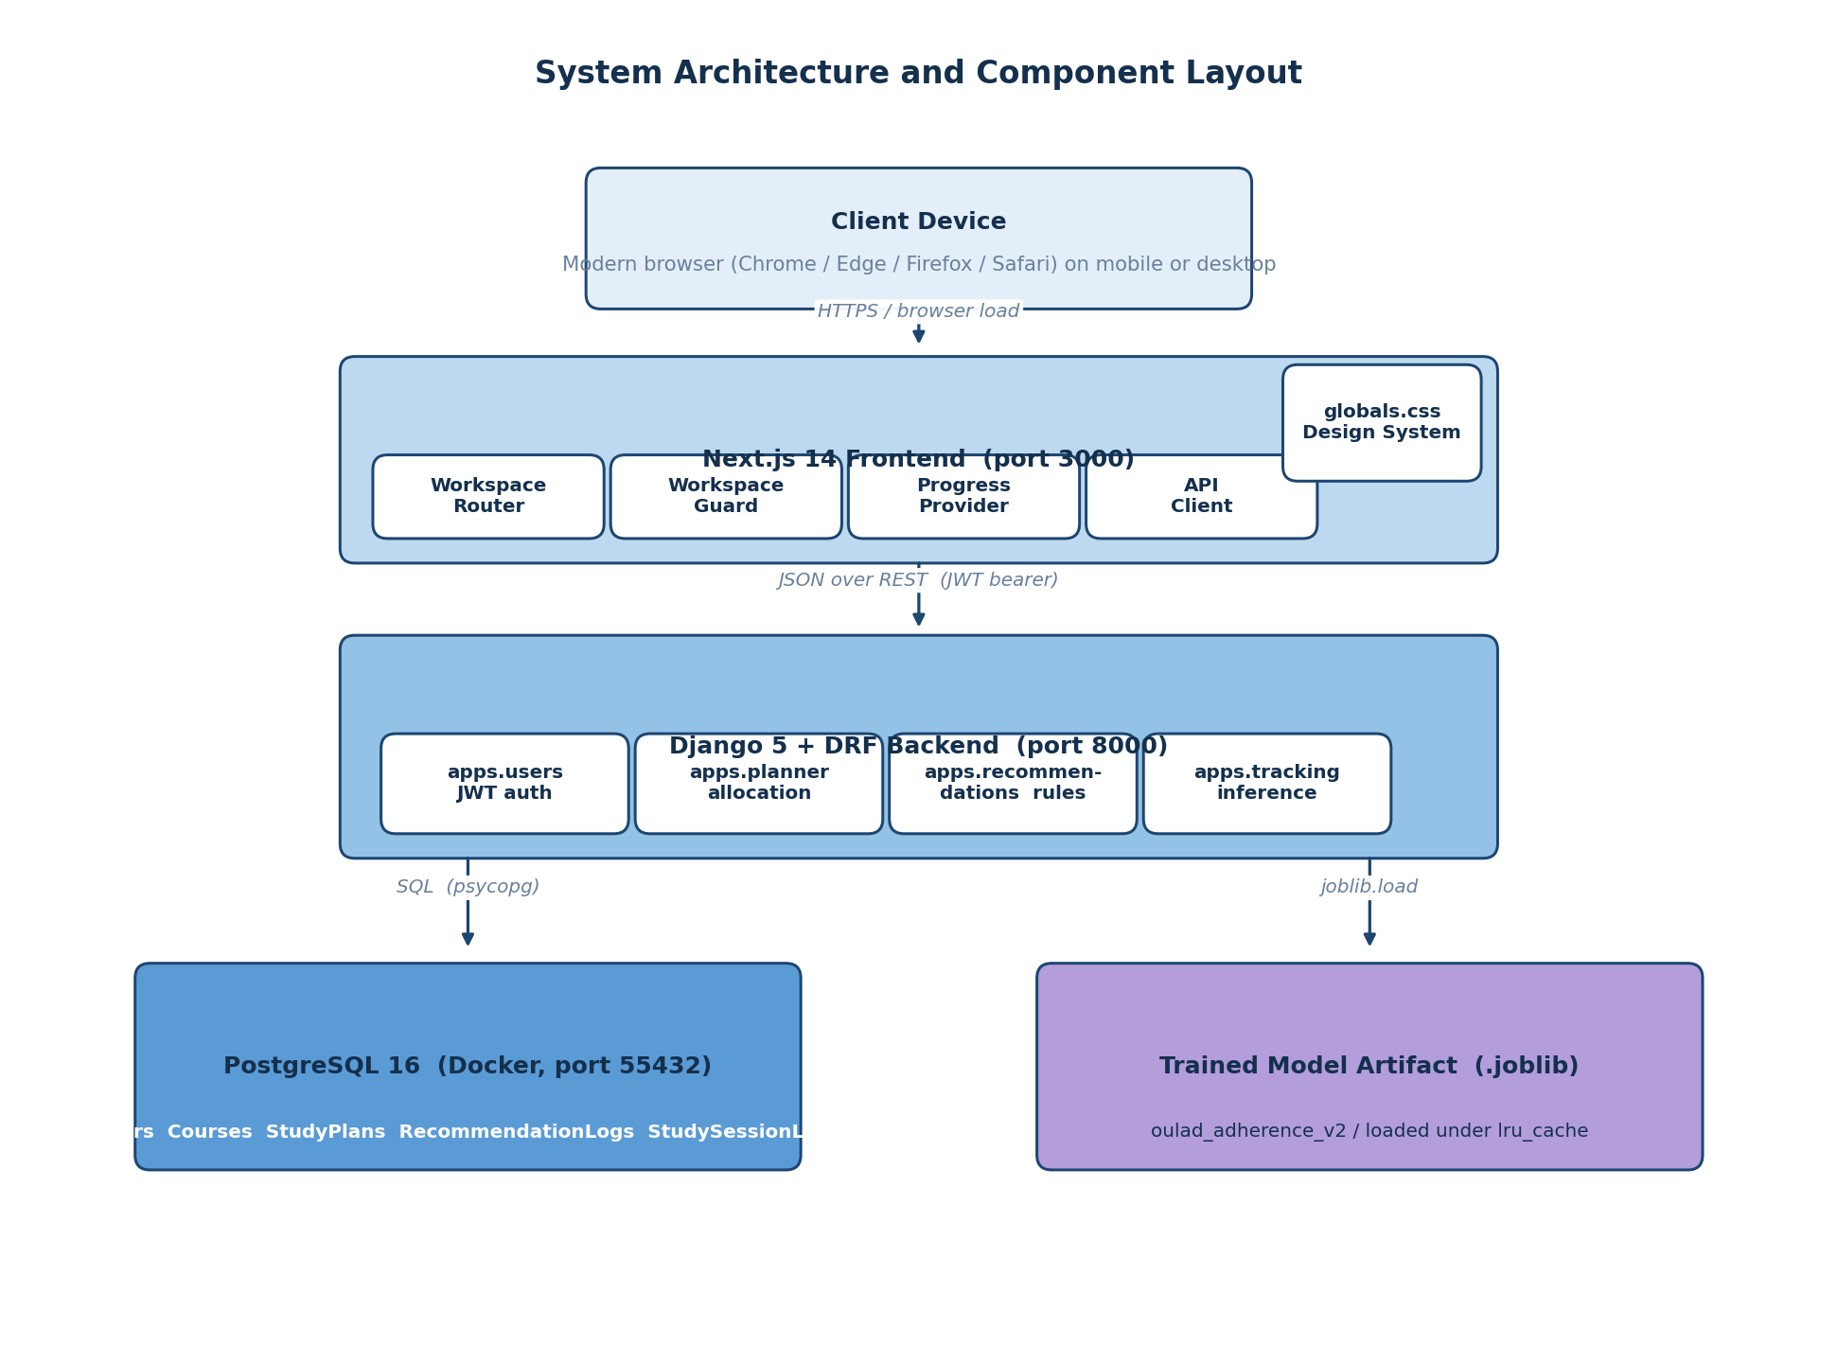
Figure A.1: System architecture and component layout, showing the layered deployment of the Next.js client, the Django REST backend with its four apps, the PostgreSQL database and the trained adherence model artifact.
Entity Relationship Diagram
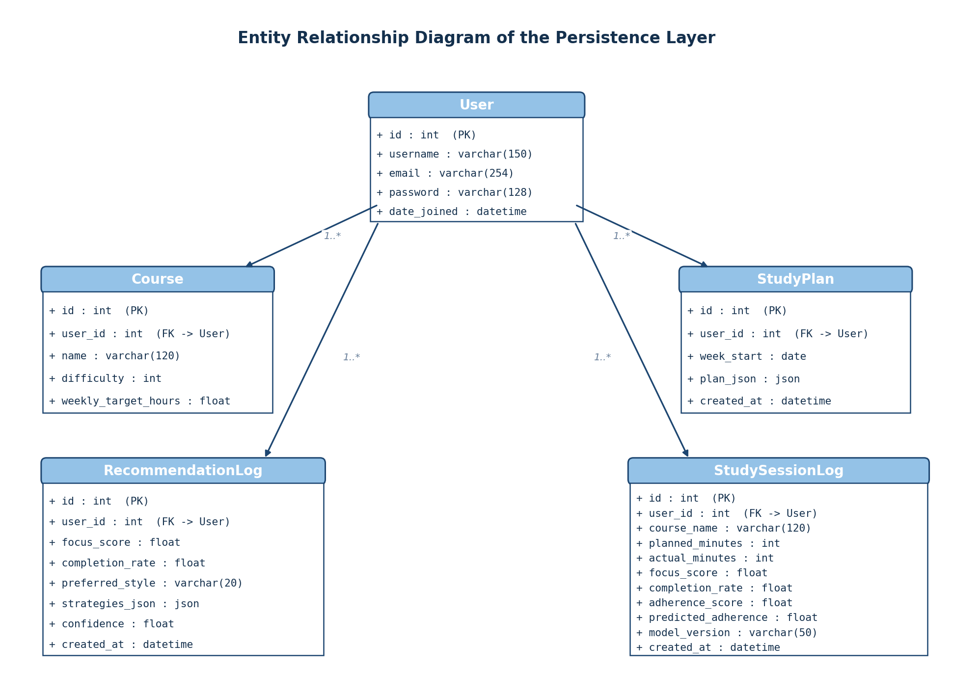
Figure A.2: Entity relationship diagram of the persistence layer, showing the User entity at the centre and the four related tables (Course, StudyPlan, RecommendationLog and StudySessionLog) each linked through a foreign key on the user identifier.
Machine Learning Pipeline Diagram
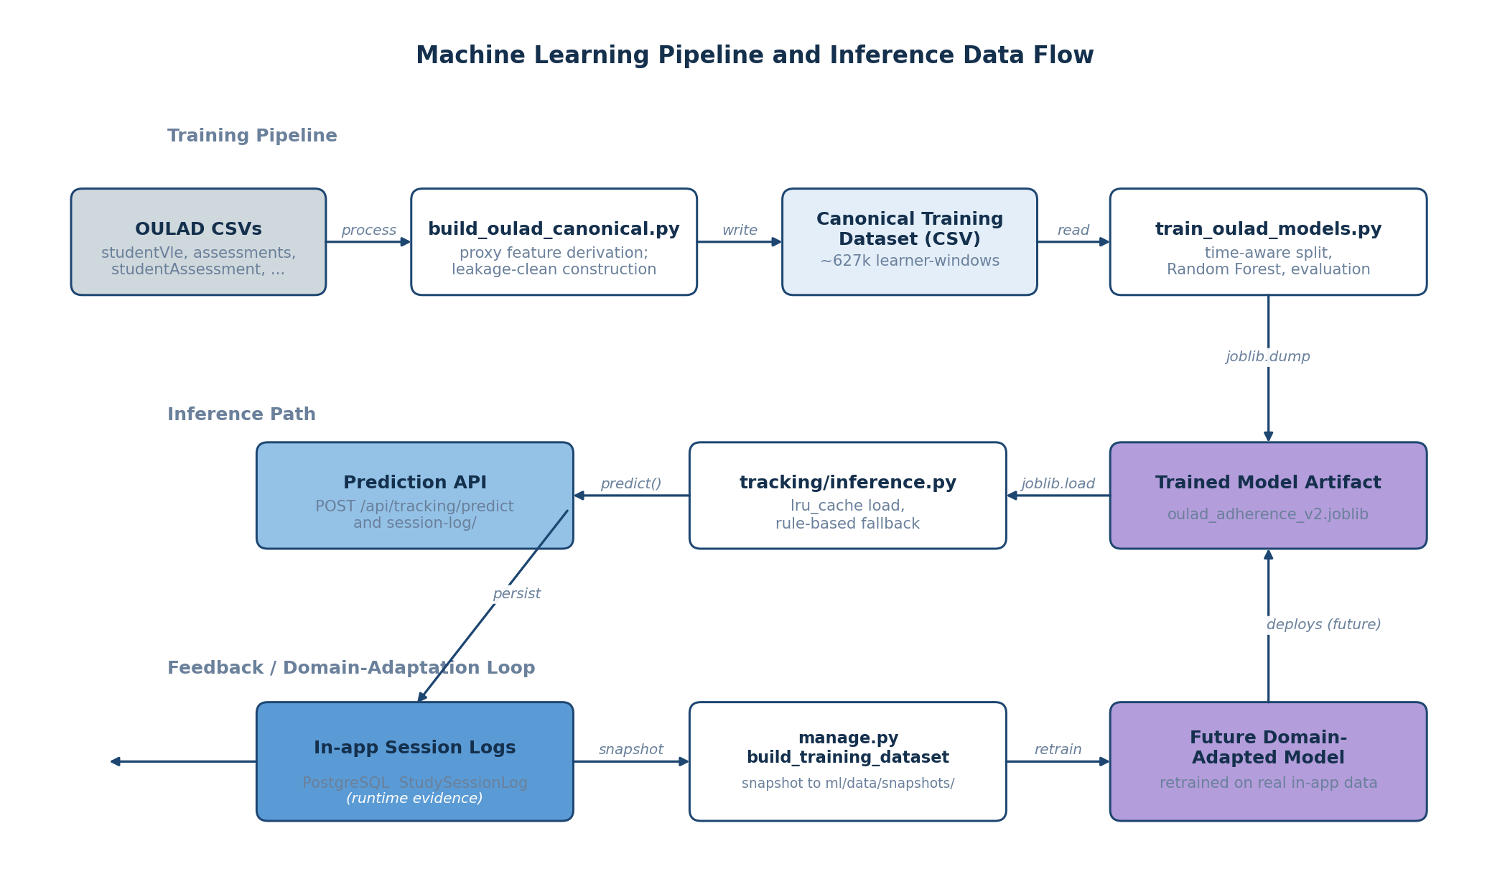
Figure A.3: Machine learning pipeline and inference data flow, showing the training pipeline that builds the canonical dataset from OULAD and trains the Random Forest model, the inference path through the tracking module, and the feedback loop that supports future domain adaptation from in-app data.
- Program Source Codes
The complete source code of the project is available at the GitHub repository https://github.com/kene-obiekwe/cs_fyp_2026.
Pilot Demo Seeder
The pilot demo seeder is a Django management command that creates five deterministic pilot users each with a distinct adherence profile, used to populate the demonstration environment for the screenshot captures in Chapter Four. The source listing of backend/apps/users/management/commands/seed_pilot_data.py is reproduced below:
"""
Seed deterministic pilot demo data for Chapter 4 screenshots and end-to-end demos.

Creates five pilot users with distinct adherence/focus profiles, three courses each,
one study plan, a handful of recommendation logs, and roughly 18 session logs
spread over the last 28 days. Timestamps are backdated so the planner's 30-day
adherence-factor lookup and the progress dashboard's history paging both show
meaningful content immediately.

This is demo data for system validation, NOT real pilot user feedback. Real pilot
feedback is collected separately and remains future work.

Re-running the command is safe: it uses get_or_create for users and courses, and
clears prior plans/recommendations/sessions for the pilot accounts before
re-seeding so the data stays deterministic across runs.

Usage (from backend/):

python manage.py seed_pilot_data
python manage.py seed_pilot_data --reset
"""

from __future__ import annotations

import random
from dataclasses import dataclass
from datetime import timedelta
from typing import Iterable

from django.contrib.auth.models import User
from django.core.management.base import BaseCommand
from django.db import transaction
from django.utils import timezone

from apps.planner.models import Course, StudyPlan
from apps.planner.services import generate_plan
from apps.recommendations.models import RecommendationLog
from apps.recommendations.services import get_recommendations
from apps.tracking.inference import build_feature_payload, predict_adherence
from apps.tracking.models import StudySessionLog

@dataclass(frozen=True)
class PilotProfile:
username: str
full_label: str
preferred_style: str
adherence_mean: float # baseline ratio of actual / planned minutes
adherence_jitter: float # +- noise applied per session
focus_mean: float
completion_mean: float
sessions_per_week: int # roughly how many sessions to seed per 7-day window

PILOTS: tuple[PilotProfile, ...] = (
PilotProfile(
username="pilot_consistent",
full_label="Consistent high adherer (visual learner)",
preferred_style="visual",
adherence_mean=0.92,
adherence_jitter=0.08,
focus_mean=0.82,
completion_mean=0.84,
sessions_per_week=5,
),
PilotProfile(
username="pilot_struggling",
full_label="Struggling learner (mixed approach)",
preferred_style="mixed",
adherence_mean=0.45,
adherence_jitter=0.15,
focus_mean=0.40,
completion_mean=0.42,
sessions_per_week=3,
),
PilotProfile(
username="pilot_improving",
full_label="Improving practice-oriented learner",
preferred_style="practice",
adherence_mean=0.70,
adherence_jitter=0.12,
focus_mean=0.65,
completion_mean=0.68,
sessions_per_week=4,
),
PilotProfile(
username="pilot_declining",
full_label="Declining reading-oriented learner",
preferred_style="reading",
adherence_mean=0.60,
adherence_jitter=0.18,
focus_mean=0.55,
completion_mean=0.55,
sessions_per_week=4,
),
PilotProfile(
username="pilot_average",
full_label="Average mixed learner",
preferred_style="mixed",
adherence_mean=0.75,
adherence_jitter=0.10,
focus_mean=0.70,
completion_mean=0.72,
sessions_per_week=4,
),
)

PILOT_PASSWORD = "Pilot12345!" # documented in docs/pilot-demo-guide.md

COURSE_CATALOG: tuple[tuple[str, int, float], ...] = (
# (name, difficulty 1-5, weekly_target_hours)
("CSC 401 Algorithms", 4, 6.0),
("MTH 401 Numerical Methods", 5, 5.0),
("STA 401 Probability Models", 3, 4.0),
("PHY 301 Modern Physics", 3, 3.0),
("ENG 401 Software Engineering", 4, 5.0),
)

# Each pilot picks three courses by index (deterministic per pilot)
PILOT_COURSE_INDICES = {
"pilot_consistent": (0, 1, 4),
"pilot_struggling": (0, 2, 3),
"pilot_improving": (1, 2, 4),
"pilot_declining": (0, 3, 4),
"pilot_average": (0, 1, 2),
}

SEED_DAYS_WINDOW = 28

def _clamp(value: float, lo: float = 0.0, hi: float = 1.0) -> float:
return max(lo, min(hi, value))

def _bounded_normal(rng: random.Random, mean: float, jitter: float) -> float:
return _clamp(rng.gauss(mean, jitter))

class Command(BaseCommand):
help = "Seed deterministic pilot demo data for Chapter 4 screenshots and end-to-end demos."

def add_arguments(self, parser) -> None:
parser.add_argument(
"--reset",
action="store_true",
help="Delete prior pilot users entirely before reseeding (default keeps users, clears their data).",
)

@transaction.atomic
def handle(self, *args, **options) -> None:
reset = bool(options.get("reset"))
rng = random.Random(20260529)

now = timezone.now()
seed_start = now - timedelta(days=SEED_DAYS_WINDOW)

if reset:
deleted, _ = User.objects.filter(username__in=[p.username for p in PILOTS]).delete()
self.stdout.write(self.style.WARNING(f"Reset: deleted {deleted} pilot user records and cascaded data."))

for profile in PILOTS:
user = self._upsert_user(profile)
self._clear_existing_data(user)
courses = self._upsert_courses(user, profile)
plan = self._seed_plan(user, courses, now)
self._seed_recommendations(user, profile, plan, seed_start, now)
self._seed_sessions(user, profile, courses, seed_start, now, rng)
self.stdout.write(self.style.SUCCESS(f"Seeded pilot: {user.username} ({profile.full_label})"))

self.stdout.write(self.style.SUCCESS(""))
self.stdout.write(self.style.SUCCESS(f"Done. {len(PILOTS)} pilot users seeded. Password for all: {PILOT_PASSWORD}"))
self.stdout.write(self.style.SUCCESS("See docs/pilot-demo-guide.md for the screenshot checklist."))

# -- helpers ----------------------------------------------------------------

def _upsert_user(self, profile: PilotProfile) -> User:
user, created = User.objects.get_or_create(
username=profile.username,
defaults={"email": f"{profile.username}@studyplanner.local"},
)
user.set_password(PILOT_PASSWORD)
user.email = f"{profile.username}@studyplanner.local"
user.save()
if created:
self.stdout.write(f" + created user {profile.username}")
return user

def _clear_existing_data(self, user: User) -> None:
StudySessionLog.objects.filter(user=user).delete()
RecommendationLog.objects.filter(user=user).delete()
StudyPlan.objects.filter(user=user).delete()
# Courses are kept (re-upserted) to preserve external referential pointers

def _upsert_courses(self, user: User, profile: PilotProfile) -> list[Course]:
indices = PILOT_COURSE_INDICES[profile.username]
result: list[Course] = []
for idx in indices:
name, difficulty, weekly = COURSE_CATALOG[idx]
course, _ = Course.objects.update_or_create(
user=user,
name=name,
defaults={"difficulty": difficulty, "weekly_target_hours": weekly},
)
result.append(course)
return result

def _seed_plan(self, user: User, courses: list[Course], now) -> StudyPlan:
course_payload = [{"name": c.name, "difficulty": c.difficulty} for c in courses]
total_hours = sum(c.weekly_target_hours for c in courses)
allocations = generate_plan(total_hours, course_payload)
week_start = (now - timedelta(days=now.weekday())).date()
plan = StudyPlan.objects.create(
user=user,
week_start=week_start,
plan_json={
"total_available_hours": total_hours,
"courses": course_payload,
"allocations": allocations,
"adherence_adjustments": {},
},
)
# Backdate the plan to the start of the seed window so the planner history
# shows it among older entries rather than always as "today".
StudyPlan.objects.filter(pk=plan.pk).update(created_at=now - timedelta(days=SEED_DAYS_WINDOW // 2))
return plan

def _seed_recommendations(
self,
user: User,
profile: PilotProfile,
plan: StudyPlan,
seed_start,
now,
) -> None:
# Three recommendation events: at start of window, midpoint, near present.
markers = [seed_start, seed_start + timedelta(days=SEED_DAYS_WINDOW // 2), now - timedelta(days=1)]
for marker in markers:
strategies, confidence = get_recommendations(
focus_score=profile.focus_mean,
completion_rate=profile.completion_mean,
preferred_style=profile.preferred_style,
)
log = RecommendationLog.objects.create(
user=user,
focus_score=profile.focus_mean,
completion_rate=profile.completion_mean,
preferred_style=profile.preferred_style,
strategies_json=strategies,
confidence=confidence,
)
RecommendationLog.objects.filter(pk=log.pk).update(created_at=marker)

def _seed_sessions(
self,
user: User,
profile: PilotProfile,
courses: list[Course],
seed_start,
now,
rng: random.Random,
) -> None:
total_sessions = max(1, int(profile.sessions_per_week * SEED_DAYS_WINDOW / 7))
session_gap_seconds = int((now - seed_start).total_seconds() / total_sessions)

course_cycle: Iterable[Course] = _round_robin(courses)
recent_dates: list = [] # rolling window for sessions_last_7_days
for i, course in zip(range(total_sessions), course_cycle):
planned_minutes = rng.choice([60, 75, 90, 105, 120])
adherence_ratio = _bounded_normal(rng, profile.adherence_mean, profile.adherence_jitter)
actual_minutes = max(0, int(round(planned_minutes * adherence_ratio)))
adherence_score = round(min(1.0, actual_minutes / max(1, planned_minutes)), 2)
focus_score = round(_bounded_normal(rng, profile.focus_mean, profile.adherence_jitter / 2), 2)
completion_rate = round(_bounded_normal(rng, profile.completion_mean, profile.adherence_jitter / 2), 2)

target_ts = seed_start + timedelta(seconds=session_gap_seconds * i)

# Compute the same rolling feature inputs that SessionLogView would
# compute at log-time, so predicted_adherence reflects the model on
# realistic state rather than zeros.
cutoff = target_ts - timedelta(days=7)
recent_dates = [d for d in recent_dates if d >= cutoff]
recent_dates.append(target_ts)
sessions_last_7_days = len(recent_dates)
created_at_offset_days = (target_ts - seed_start).days
consistency_score = min(1.0, sessions_last_7_days / 7.0)

feature_payload = build_feature_payload(
planned_minutes=planned_minutes,
completion_rate=completion_rate,
sessions_last_7_days=sessions_last_7_days,
focus_score=focus_score,
consistency_score=consistency_score,
created_at_offset_days=created_at_offset_days,
)
predicted_adherence, model_version = predict_adherence(feature_payload)

log = StudySessionLog.objects.create(
user=user,
course_name=course.name,
planned_minutes=planned_minutes,
actual_minutes=actual_minutes,
focus_score=focus_score,
completion_rate=completion_rate,
adherence_score=adherence_score,
predicted_adherence=predicted_adherence,
model_version=model_version,
)
StudySessionLog.objects.filter(pk=log.pk).update(created_at=target_ts)

def _round_robin(items: list):
while True:
for item in items:
yield item
Adherence Model Training Script
The adherence model training script trains the Random Forest regression model on the canonical training dataset, performs the time-aware split, conducts a hyperparameter search, evaluates the result on the held-out test set, and saves the model artifact and evaluation plots. The source listing of backend/ml/train_oulad_models.py is reproduced below:
import argparse
import json
from pathlib import Path

import joblib
import numpy as np
import pandas as pd
import matplotlib.pyplot as plt
from sklearn.impute import SimpleImputer
from sklearn.metrics import mean_absolute_error, mean_squared_error, r2_score
from sklearn.model_selection import train_test_split
from sklearn.pipeline import Pipeline
from sklearn.ensemble import RandomForestRegressor

FEATURE_COLUMNS = [
"planned_minutes",
"completion_rate",
"sessions_last_7_days",
"focus_score",
"help_seeking_rate",
"consistency_score",
"avg_quiz_score_recent",
"created_at",
]

QUALITY_COLUMNS = list(dict.fromkeys(FEATURE_COLUMNS + ["actual_minutes"]))

def parse_args() -> argparse.Namespace:
parser = argparse.ArgumentParser(description="Train adherence model on OULAD canonical dataset.")
parser.add_argument(
"--data",
default="backend/ml/data/oulad/training_dataset.csv",
help="Path to canonical OULAD training CSV.",
)
parser.add_argument(
"--output-dir",
default="backend/ml/models",
help="Directory to write model artifacts.",
)
parser.add_argument(
"--report-dir",
default="backend/ml/reports",
help="Directory to write training reports.",
)
parser.add_argument(
"--test-size",
type=float,
default=0.2,
help="Test split size (default: 0.2).",
)
parser.add_argument(
"--val-size",
type=float,
default=0.1,
help="Validation split size (default: 0.1).",
)
parser.add_argument(
"--split",
choices=["random", "time"],
default="time",
help="Split strategy: random or time-based (default: time).",
)
parser.add_argument(
"--limit",
type=int,
default=200000,
help="Optional row limit for faster runs (0 means all rows).",
)
parser.add_argument(
"--n-estimators",
type=int,
default=200,
help="Number of trees for RandomForestRegressor (default: 200).",
)
return parser.parse_args()

def build_splits(df: pd.DataFrame, test_size: float, val_size: float, split: str):
if test_size <= 0 or val_size < 0:
raise ValueError("test_size must be > 0 and val_size must be >= 0")
if test_size + val_size >= 1:
raise ValueError("test_size + val_size must be < 1")

if split == "time":
df = df.sort_values("created_at")
n = len(df)
n_train = int(n * (1 - test_size - val_size))
n_val = int(n * val_size)
train_df = df.iloc[:n_train]
val_df = df.iloc[n_train : n_train + n_val]
test_df = df.iloc[n_train + n_val :]
return train_df, val_df, test_df

train_val_df, test_df = train_test_split(df, test_size=test_size, random_state=42)
relative_val = val_size / (1 - test_size)
train_df, val_df = train_test_split(train_val_df, test_size=relative_val, random_state=42)
return train_df, val_df, test_df

def data_quality_checks(df: pd.DataFrame) -> dict:
checks = {
"row_count": int(len(df)),
"duplicate_rows": int(df.duplicated().sum()),
"missing_rate": df[QUALITY_COLUMNS + ["adherence_score"]].isna().mean().round(4).to_dict(),
"adherence_out_of_bounds": int(((df["adherence_score"] < 0) | (df["adherence_score"] > 1)).sum()),
"completion_rate_out_of_bounds": int(((df["completion_rate"] < 0) | (df["completion_rate"] > 1)).sum()),
"planned_minutes_non_positive": int((df["planned_minutes"] <= 0).sum()),
"actual_minutes_negative": int((df["actual_minutes"] < 0).sum()),
}
return checks

def score_metrics(y_true: np.ndarray, y_pred: np.ndarray) -> dict:
return {
"mae": float(mean_absolute_error(y_true, y_pred)),
"rmse": float(np.sqrt(mean_squared_error(y_true, y_pred))),
"r2": float(r2_score(y_true, y_pred)),
}

def save_plots(
y_true: np.ndarray,
y_pred: np.ndarray,
baseline_pred: np.ndarray,
feature_importances: dict,
output_dir: Path,
):
output_dir.mkdir(parents=True, exist_ok=True)

sample_size = min(len(y_true), 15000)
if sample_size < len(y_true):
idx = np.random.RandomState(42).choice(len(y_true), size=sample_size, replace=False)
y_true = y_true[idx]
y_pred = y_pred[idx]
baseline_pred = baseline_pred[idx]

plt.figure(figsize=(6, 5))
plt.scatter(y_true, y_pred, alpha=0.25, s=8)
plt.plot([0, 1], [0, 1], color="black", linestyle="--", linewidth=1)
plt.xlabel("True adherence")
plt.ylabel("Predicted adherence")
plt.title("Predicted vs True (Sample)")
scatter_path = output_dir / "predicted_vs_true.png"
plt.tight_layout()
plt.savefig(scatter_path, dpi=160)
plt.close()

residuals = y_true - y_pred
plt.figure(figsize=(6, 4))
plt.hist(residuals, bins=50, color="#4c78a8", alpha=0.85)
plt.xlabel("Residual (true - predicted)")
plt.ylabel("Count")
plt.title("Residual Distribution")
resid_path = output_dir / "residuals_hist.png"
plt.tight_layout()
plt.savefig(resid_path, dpi=160)
plt.close()

baseline_metrics = score_metrics(y_true, baseline_pred)
model_metrics = score_metrics(y_true, y_pred)
labels = ["MAE", "RMSE", "R2"]
baseline_vals = [baseline_metrics["mae"], baseline_metrics["rmse"], baseline_metrics["r2"]]
model_vals = [model_metrics["mae"], model_metrics["rmse"], model_metrics["r2"]]

x = np.arange(len(labels))
width = 0.35
plt.figure(figsize=(6, 4))
plt.bar(x - width / 2, baseline_vals, width, label="Baseline")
plt.bar(x + width / 2, model_vals, width, label="Model")
plt.xticks(x, labels)
plt.title("Baseline vs Model Metrics")
plt.legend()
metrics_path = output_dir / "baseline_vs_model.png"
plt.tight_layout()
plt.savefig(metrics_path, dpi=160)
plt.close()

if feature_importances:
names = list(feature_importances.keys())
values = list(feature_importances.values())
order = np.argsort(values)
plt.figure(figsize=(7, 5))
plt.barh([names[i] for i in order], [values[i] for i in order])
plt.xlabel("Importance")
plt.title("Feature Importance")
feat_path = output_dir / "feature_importance.png"
plt.tight_layout()
plt.savefig(feat_path, dpi=160)
plt.close()

return {
"predicted_vs_true": str(scatter_path),
"residuals_hist": str(resid_path),
"baseline_vs_model": str(metrics_path),
"feature_importance": str(output_dir / "feature_importance.png"),
}

def main() -> None:
args = parse_args()
data_path = Path(args.data)
if not data_path.exists():
raise SystemExit(f"Training data not found: {data_path}")

df = pd.read_csv(data_path)
if args.limit and args.limit > 0 and len(df) > args.limit:
if args.split == "time":
df = df.sort_values("created_at").tail(args.limit)
else:
df = df.sample(n=args.limit, random_state=42)

quality = data_quality_checks(df)

train_df, val_df, test_df = build_splits(df, args.test_size, args.val_size, args.split)

X_train = train_df[FEATURE_COLUMNS]
y_train = train_df["adherence_score"]
X_val = val_df[FEATURE_COLUMNS]
y_val = val_df["adherence_score"]
X_test = test_df[FEATURE_COLUMNS]
y_test = test_df["adherence_score"]

baseline_pred = np.full_like(y_test, y_train.mean(), dtype=float)
baseline_metrics = score_metrics(y_test, baseline_pred)

param_grid = [
{"n_estimators": args.n_estimators, "max_depth": None, "min_samples_leaf": 1},
{"n_estimators": args.n_estimators, "max_depth": 12, "min_samples_leaf": 2},
{"n_estimators": args.n_estimators, "max_depth": 20, "min_samples_leaf": 5},
]

best = {"rmse": float("inf"), "params": None, "model": None}
for params in param_grid:
model = Pipeline(
steps=[
("imputer", SimpleImputer(strategy="median")),
(
"regressor",
RandomForestRegressor(
n_estimators=params["n_estimators"],
max_depth=params["max_depth"],
min_samples_leaf=params["min_samples_leaf"],
random_state=42,
n_jobs=-1,
),
),
]
)
model.fit(X_train, y_train)
val_pred = model.predict(X_val)
rmse = float(np.sqrt(mean_squared_error(y_val, val_pred)))
if rmse < best["rmse"]:
best = {"rmse": rmse, "params": params, "model": model}

best_params = best["params"]
final_model = best["model"]

# Refit on train + val for final evaluation
X_train_full = pd.concat([X_train, X_val], axis=0)
y_train_full = pd.concat([y_train, y_val], axis=0)
final_model.fit(X_train_full, y_train_full)

preds = final_model.predict(X_test)
model_metrics = score_metrics(y_test, preds)

output_dir = Path(args.output_dir)
output_dir.mkdir(parents=True, exist_ok=True)
model_path = output_dir / "oulad_adherence_model.joblib"
joblib.dump(final_model, model_path)

report_dir = Path(args.report_dir)
report_dir.mkdir(parents=True, exist_ok=True)
report_path = report_dir / "oulad_training_report.json"

plot_dir = report_dir / "oulad_plots"
feature_importances = {}
regressor = final_model.named_steps.get("regressor")
if hasattr(regressor, "feature_importances_"):
feature_importances = {
name: float(val)
for name, val in zip(FEATURE_COLUMNS, regressor.feature_importances_)
}
plot_paths = save_plots(
y_test.to_numpy(),
preds,
baseline_pred,
feature_importances,
plot_dir,
)

report = {
"data_path": str(data_path),
"row_count": int(len(df)),
"feature_columns": FEATURE_COLUMNS,
"data_quality": quality,
"feature_importance": feature_importances,
"split": args.split,
"val_size": args.val_size,
"test_size": args.test_size,
"limit": args.limit,
"best_params": best_params,
"baseline_metrics": baseline_metrics,
"model_metrics": model_metrics,
"model_path": str(model_path),
"plots": plot_paths,
}

report_path.write_text(json.dumps(report, indent=2), encoding="utf-8")

print("Training complete")
print(json.dumps(report, indent=2))

if __name__ == "__main__":
main()
OULAD Canonical Schema Builder
The canonical schema builder adapts the Open University Learning Analytics Dataset into the project canonical training schema using the proxy definitions documented in Chapter Four. The source listing of backend/ml/build_oulad_canonical.py is reproduced below:
import argparse
import json
from datetime import datetime
from pathlib import Path

import numpy as np
import pandas as pd

CANONICAL_COLUMNS = [
"user_id",
"planned_minutes",
"actual_minutes",
"completion_rate",
"sessions_last_7_days",
"focus_score",
"help_seeking_rate",
"consistency_score",
"avg_quiz_score_recent",
"created_at",
"adherence_score",
"strategy_label",
]

def parse_args() -> argparse.Namespace:
parser = argparse.ArgumentParser(
description="Build a canonical training dataset from OULAD using proxy features."
)
parser.add_argument(
"--input-dir",
default="dataset",
help="Directory containing OULAD CSV files.",
)
parser.add_argument(
"--output-dir",
default="backend/ml/data/oulad",
help="Directory to write training_dataset.csv and metadata.json.",
)
parser.add_argument(
"--window-size",
type=int,
default=7,
help="Window size in days for aggregation (default: 7).",
)
parser.add_argument(
"--clicks-per-minute",
type=float,
default=5.0,
help="Scaling factor to convert clicks to estimated minutes (default: 5).",
)
parser.add_argument(
"--chunksize",
type=int,
default=500000,
help="CSV chunk size for studentVle processing (default: 500000).",
)
return parser.parse_args()

def load_vle_map(input_dir: Path) -> pd.DataFrame:
vle_path = input_dir / "vle.csv"
vle_df = pd.read_csv(vle_path)
vle_df["activity_type"] = vle_df["activity_type"].fillna("")
help_keywords = (
"forum",
"wiki",
"collab",
"oucontent",
"resource",
"page",
"subpage",
)
vle_df["is_help"] = vle_df["activity_type"].str.contains(
"|".join(help_keywords), case=False, regex=True
)
return vle_df[["id_site", "is_help"]], list(help_keywords)

def build_activity_windows(
input_dir: Path,
vle_map: pd.DataFrame,
window_size: int,
chunksize: int,
) -> pd.DataFrame:
student_vle_path = input_dir / "studentVle.csv"

dtype = {
"code_module": "category",
"code_presentation": "category",
"id_student": "int32",
"id_site": "int32",
"date": "int16",
"sum_click": "int32",
}

daily_parts: list[pd.DataFrame] = []
for chunk in pd.read_csv(student_vle_path, dtype=dtype, chunksize=chunksize):
chunk = chunk.merge(vle_map, how="left", on="id_site")
chunk["is_help"] = chunk["is_help"].fillna(False)
chunk["window_start"] = (chunk["date"] // window_size) * window_size
chunk["help_clicks"] = np.where(chunk["is_help"], chunk["sum_click"], 0)

daily = (
chunk.groupby(
[
"id_student",
"code_module",
"code_presentation",
"window_start",
"date",
],
as_index=False,
observed=True,
)
.agg(total_clicks=("sum_click", "sum"), help_clicks=("help_clicks", "sum"))
)
daily_parts.append(daily)

daily_df = pd.concat(daily_parts, ignore_index=True)
daily_df = (
daily_df.groupby(
[
"id_student",
"code_module",
"code_presentation",
"window_start",
"date",
],
as_index=False,
observed=True,
)
.agg(total_clicks=("total_clicks", "sum"), help_clicks=("help_clicks", "sum"))
)

window_df = (
daily_df.groupby(
["id_student", "code_module", "code_presentation", "window_start"],
as_index=False,
observed=True,
)
.agg(
total_clicks=("total_clicks", "sum"),
help_clicks=("help_clicks", "sum"),
active_days=("date", "nunique"),
)
)
window_df["avg_clicks_per_active_day"] = np.where(
window_df["active_days"] > 0,
window_df["total_clicks"] / window_df["active_days"],
0,
)
return window_df

def build_assessment_windows(input_dir: Path, window_size: int) -> pd.DataFrame:
assessments_path = input_dir / "assessments.csv"
student_assess_path = input_dir / "studentAssessment.csv"

assessments = pd.read_csv(assessments_path)
student_assess = pd.read_csv(student_assess_path)

merged = student_assess.merge(assessments, how="left", on="id_assessment")
merged["assessment_date"] = np.where(
merged["date_submitted"] >= 0,
merged["date_submitted"],
merged["date"],
)
merged["window_start"] = (merged["assessment_date"] // window_size) * window_size

window_scores = (
merged.groupby(
["id_student", "code_module", "code_presentation", "window_start"],
as_index=False,
observed=True,
)
.agg(mean_score=("score", "mean"))
)
return window_scores

def clip_01(values):
if isinstance(values, pd.Series):
return values.clip(lower=0, upper=1)
return np.clip(values, 0, 1)

def main() -> None:
args = parse_args()
input_dir = Path(args.input_dir)
output_dir = Path(args.output_dir)
output_dir.mkdir(parents=True, exist_ok=True)

vle_map, help_keywords = load_vle_map(input_dir)
activity_windows = build_activity_windows(
input_dir,
vle_map,
window_size=args.window_size,
chunksize=args.chunksize,
)
assessment_windows = build_assessment_windows(input_dir, window_size=args.window_size)

window_df = activity_windows.merge(
assessment_windows,
how="left",
on=["id_student", "code_module", "code_presentation", "window_start"],
)

expected_clicks = (
window_df.groupby(
["code_module", "code_presentation", "window_start"],
as_index=False,
observed=True,
)
.agg(expected_clicks=("total_clicks", "median"))
)
window_df = window_df.merge(
expected_clicks,
how="left",
on=["code_module", "code_presentation", "window_start"],
)

clicks_per_minute = max(args.clicks_per_minute, 1e-6)
window_df["actual_minutes"] = window_df["total_clicks"] / clicks_per_minute
window_df["planned_minutes"] = window_df["expected_clicks"] / clicks_per_minute

engagement_ratio = np.where(
window_df["expected_clicks"] > 0,
window_df["total_clicks"] / window_df["expected_clicks"],
0,
)

# completion_rate is derived ONLY from assessment scores. Falling back to
# engagement_ratio (as in an earlier version) made completion_rate identical
# to adherence_score for the ~78% of rows without assessment data, producing
# severe target leakage. Leaving NaN here lets the model's median imputer
# handle missingness while keeping completion_rate and adherence_score
# derived from independent signals.
window_df["completion_rate"] = window_df["mean_score"] / 100.0

p90 = np.percentile(window_df["avg_clicks_per_active_day"], 90) if len(window_df) else 1.0
p90 = p90 if p90 > 0 else 1.0
window_df["focus_score"] = clip_01(window_df["avg_clicks_per_active_day"] / p90)

window_df["help_seeking_rate"] = np.where(
window_df["total_clicks"] > 0,
window_df["help_clicks"] / window_df["total_clicks"],
np.nan,
)

window_df["consistency_score"] = clip_01(window_df["active_days"] / args.window_size)
window_df["sessions_last_7_days"] = window_df["active_days"]
window_df["avg_quiz_score_recent"] = window_df["mean_score"] / 100.0
window_df["created_at"] = window_df["window_start"] + (args.window_size - 1)

window_df["adherence_score"] = clip_01(engagement_ratio)
window_df["strategy_label"] = ""

completion_rate_clipped = window_df["completion_rate"].clip(lower=0, upper=1)

output_df = pd.DataFrame(
{
"user_id": window_df["id_student"],
"planned_minutes": window_df["planned_minutes"],
"actual_minutes": window_df["actual_minutes"],
"completion_rate": completion_rate_clipped,
"sessions_last_7_days": window_df["sessions_last_7_days"],
"focus_score": window_df["focus_score"],
"help_seeking_rate": window_df["help_seeking_rate"],
"consistency_score": window_df["consistency_score"],
"avg_quiz_score_recent": window_df["avg_quiz_score_recent"],
"created_at": window_df["created_at"],
"adherence_score": window_df["adherence_score"],
"strategy_label": window_df["strategy_label"],
}
)

output_df = output_df[CANONICAL_COLUMNS]

output_path = output_dir / "training_dataset.csv"
output_df.to_csv(output_path, index=False)

metadata = {
"generated_at": datetime.utcnow().isoformat() + "Z",
"input_dir": str(input_dir),
"output_file": str(output_path),
"row_count": int(len(output_df)),
"window_size_days": args.window_size,
"clicks_per_minute": args.clicks_per_minute,
"help_keywords": help_keywords,
"proxy_definitions": {
"actual_minutes": "total_clicks / clicks_per_minute",
"planned_minutes": "median total_clicks per module/presentation/window / clicks_per_minute",
"completion_rate": "mean assessment score / 100 if assessment data available, else NaN (imputer handles missingness; engagement_ratio fallback was removed to avoid target leakage with adherence_score)",
"focus_score": "avg_clicks_per_active_day scaled by p90",
"help_seeking_rate": "help_clicks / total_clicks using activity_type keywords",
"consistency_score": "active_days / window_size",
"adherence_score": "total_clicks / expected_clicks (clipped)",
"created_at": "window_end_day (relative to presentation start)",
},
"missing_counts": output_df.isna().sum().to_dict(),
"notes": [
"created_at is a relative day index, not a calendar datetime.",
"strategy_label is intentionally blank because OULAD has no strategy labels.",
],
}

metadata_path = output_dir / "metadata.json"
metadata_path.write_text(json.dumps(metadata, indent=2), encoding="utf-8")

print(f"Wrote {len(output_df)} rows to {output_path}")
print(f"Metadata written to {metadata_path}")

if __name__ == "__main__":
main()

